1. You are very creative in the variables selection which is great.
2. Generally, this is a fairly complete report with most required elements.
3. My suggestion to you is to focus more on the diagnostic plots. Don’t ignore the hint when assumptions are severely violated. You need to think over the interpretation of coefficient estimates. Please check my related comments. Your model performance is not very good, which could be related to insufficient/inappropriate data treatment prior to modeling.

(The best Kaggle score of the class is 0.1261.)

# Introduction

The goal of Project 1 was to predict the final sales price (response) of each home in the Kaggle – Ames, IA dataset. Document your model selection approach and confidence.

# Data Description

The data was from Century 21 realtors. There are 1,460 observations of homes sold between 2006 and 2010 with 80 variables used to determine sales price. This was an observational study; therefore, no causal inference can be implied across the Ames, IA real estate market.

# Exploratory Analysis (updated)

Prior to the Exploratory Data Analysis (EDA) phase, the issue of significant missing data was addressed. The missing data did not appear to be coding errors, rather just a lot of variables being tracked with many missing values. Given the nature of this project with Kaggle, requiring every row, the data imputation could not eliminate entries.

The previous approach, using the mean value to fill in missing data, was not good for multivariate analysis since it hides correlations. Project 1 model results support this conclusion. Given time and current experience, a combination of median and small value imputation[1] was used. For those entries with ‘NA’ or missing values, the median value for the variable was substituted. For those entries that had a ‘0’, like ‘0 HalfBaths’, .0001 replaced the ‘0’ to allow for log transformation.

Initial analysis of the numerical variables showed that the data does not sufficiently meet the assumptions of linear regression, like linear relationship, no multicollinearity, multivariate normality, etc. A log transformation was conducted on key variables to meet the linear regression assumptions. Side by side diagrams show the initial model and then the log transformed model.

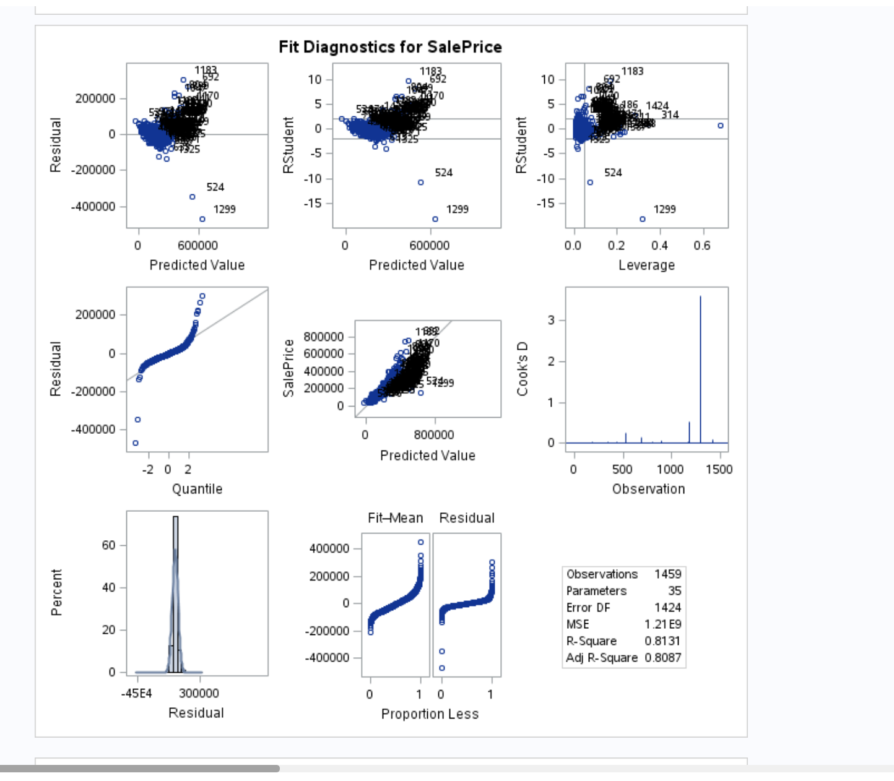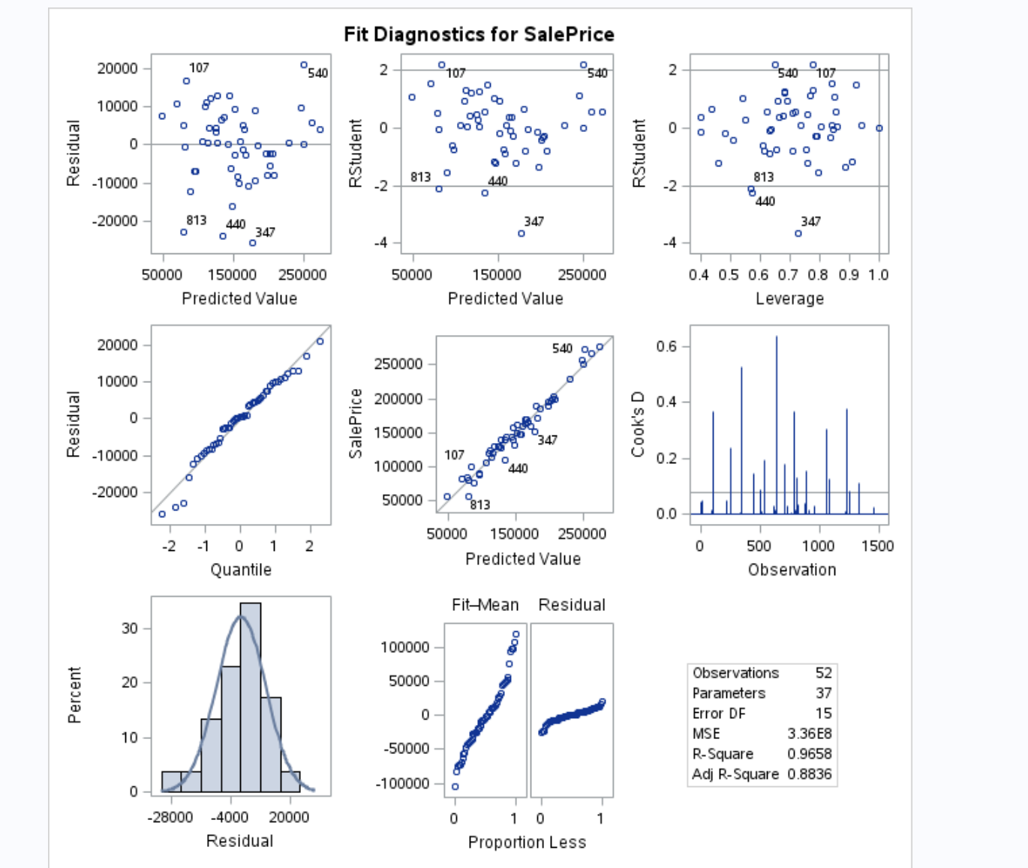

Figure 1 – Residual by Regressor - Before Log on left and After Log on right

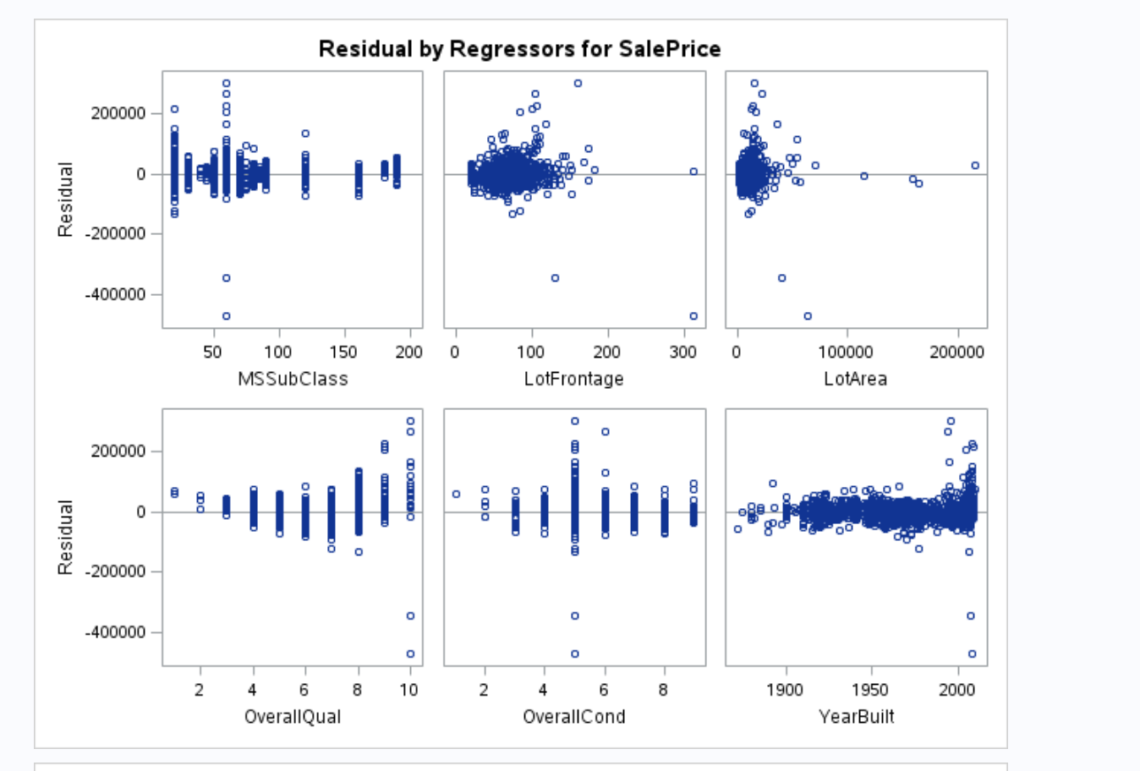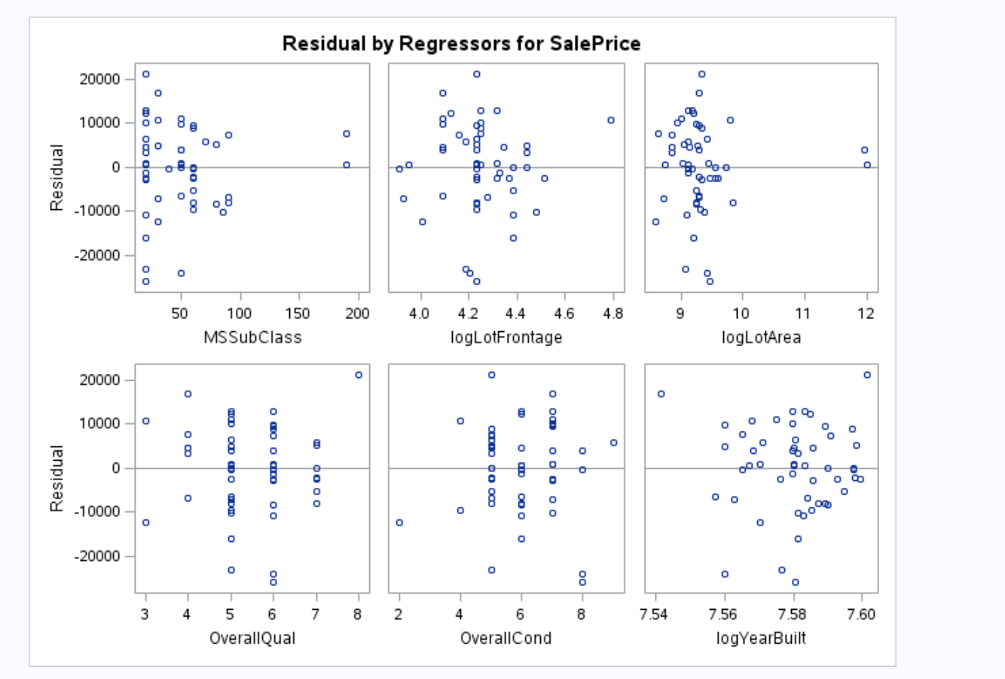

Figure 2 - Residual by Regressor - Before Log on left and After Log on right

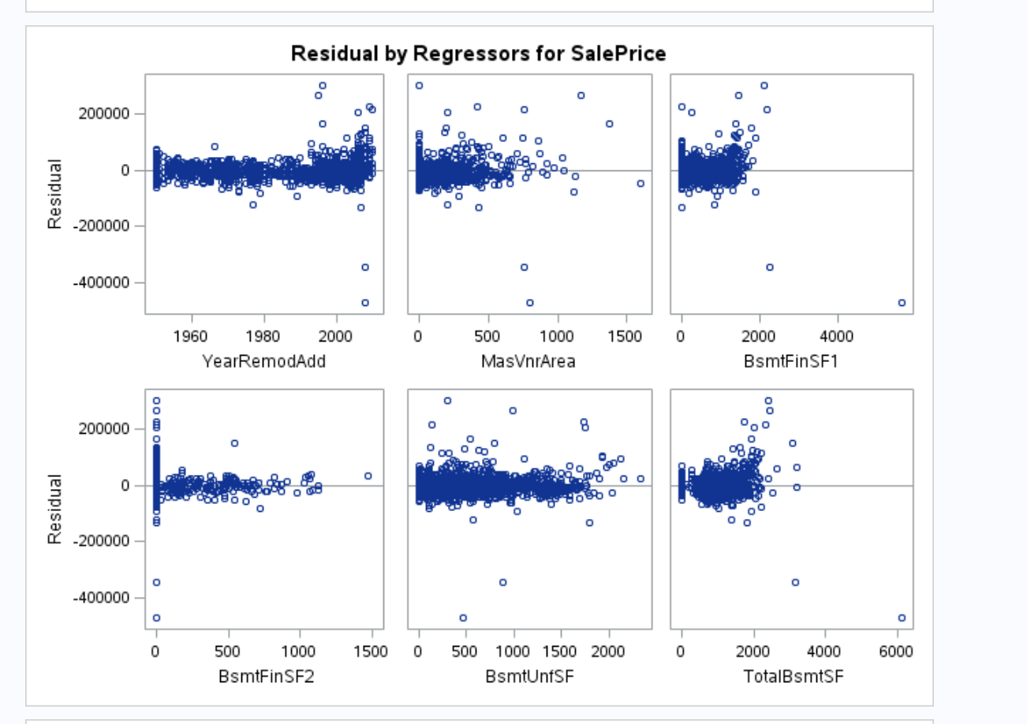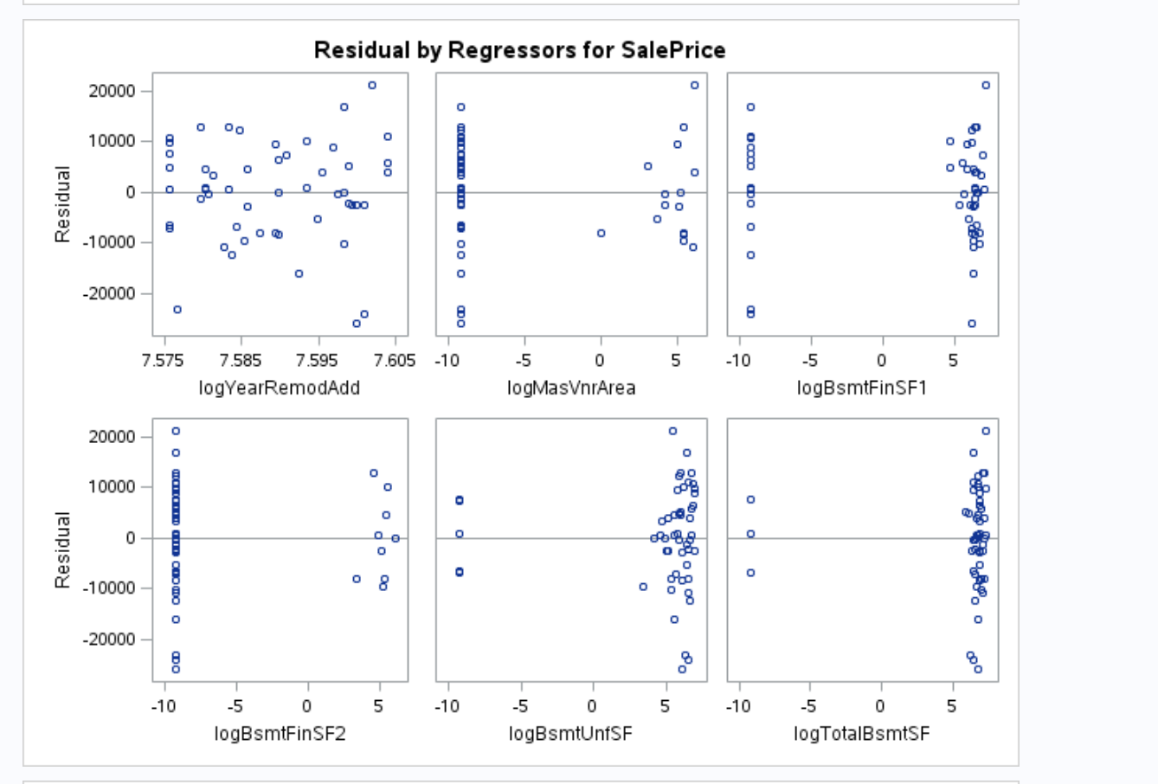

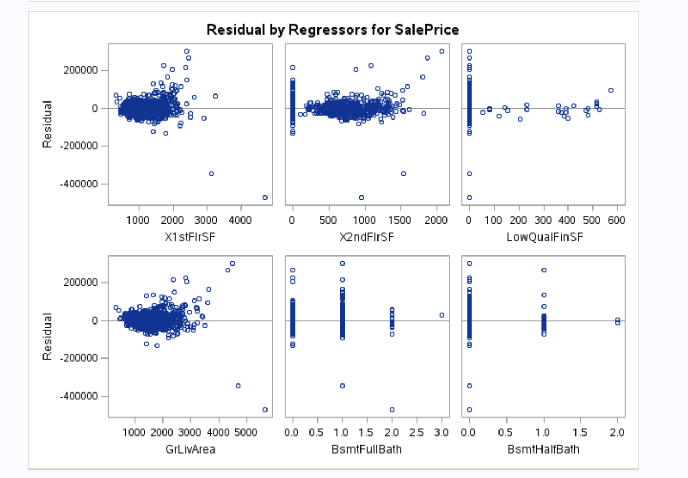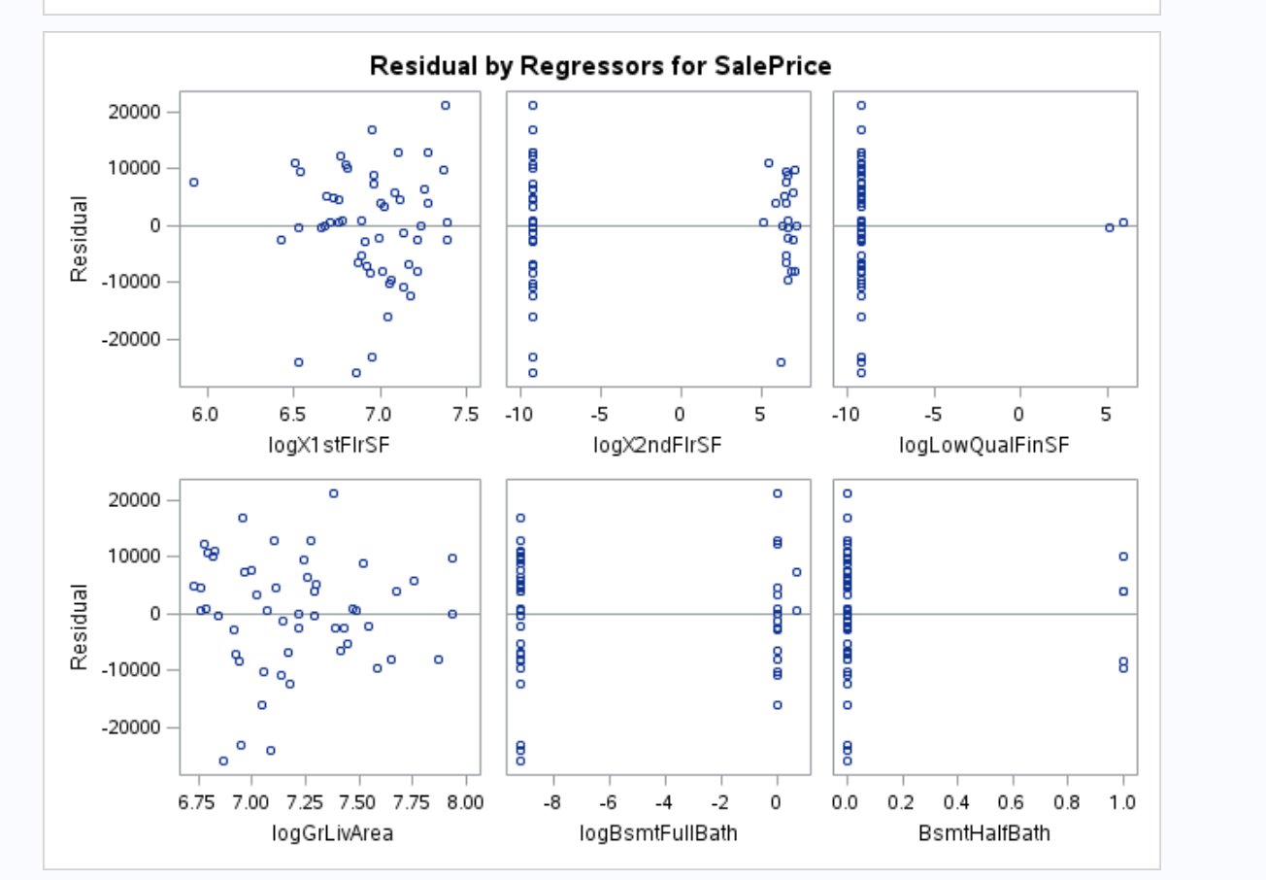

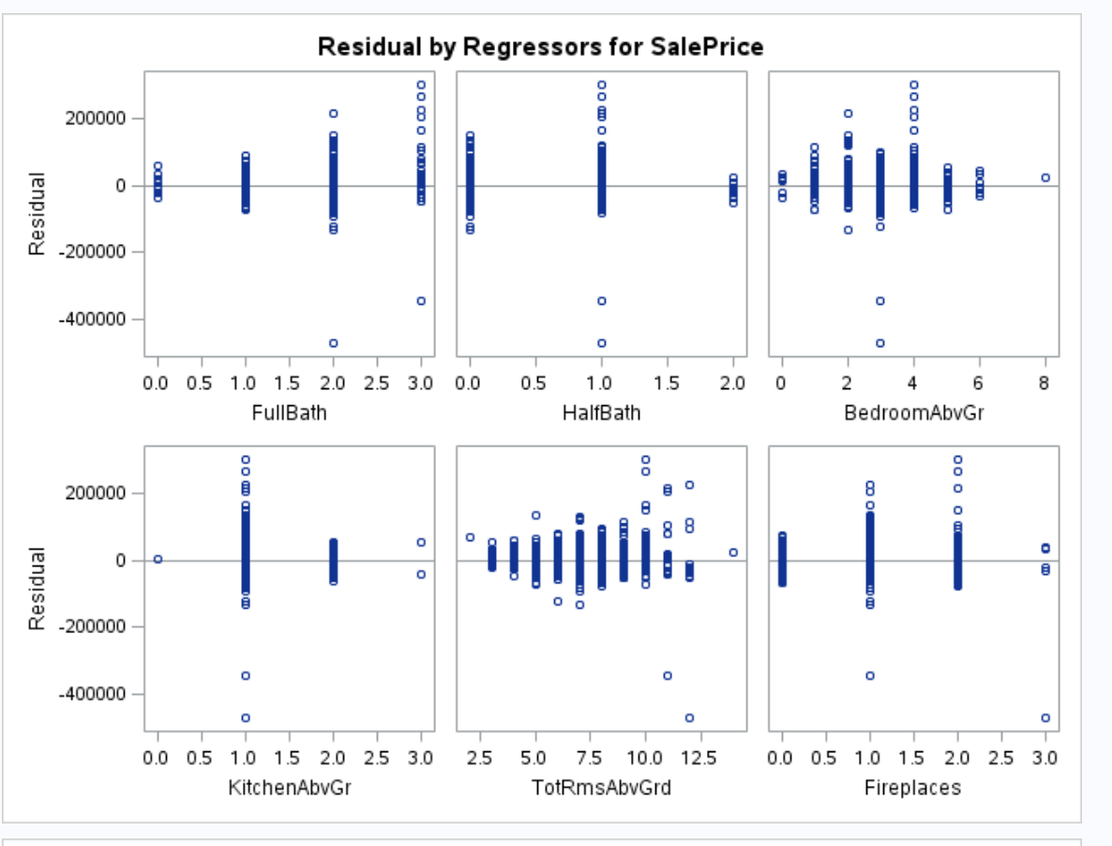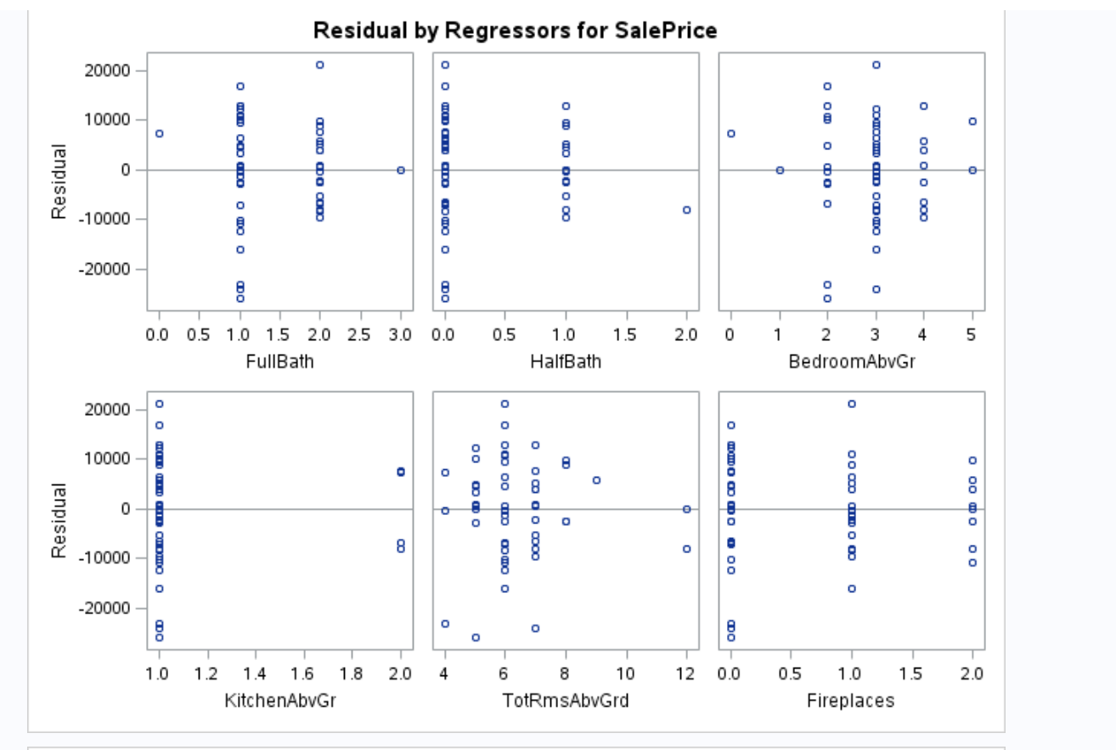

Figure 3 - Residual by Regressor - Before Log on left and After Log on right

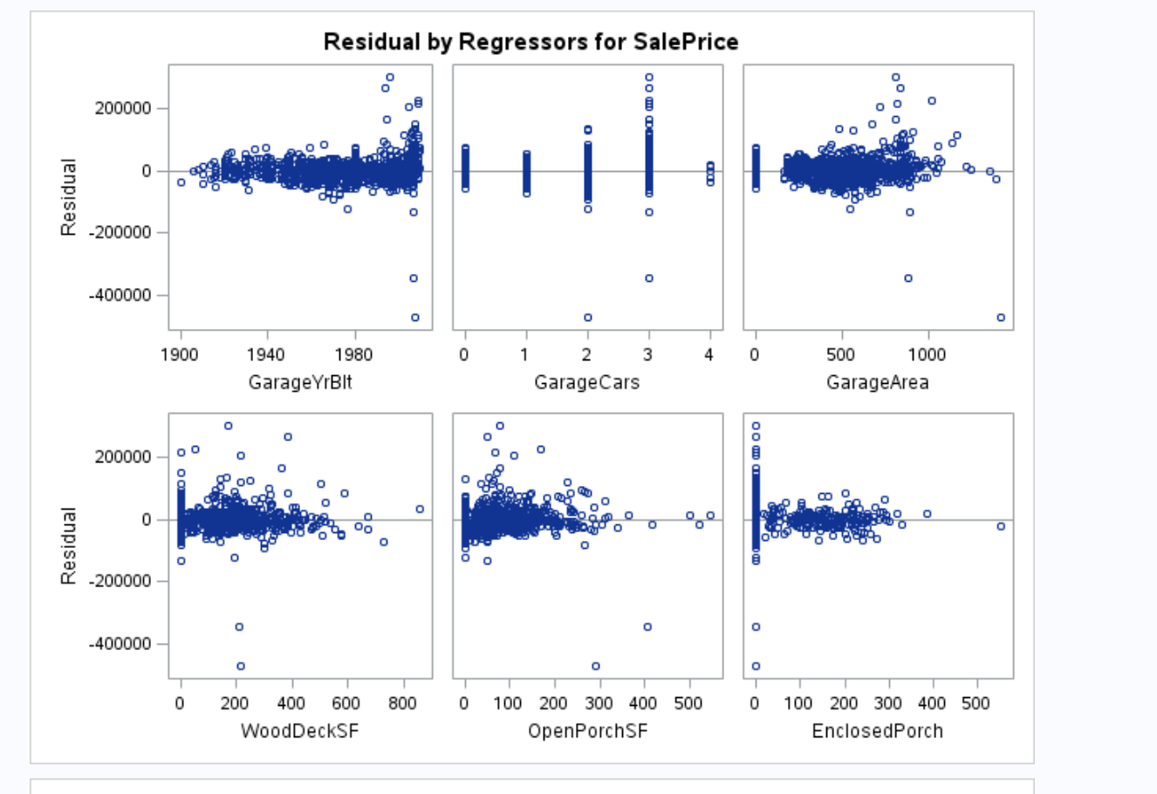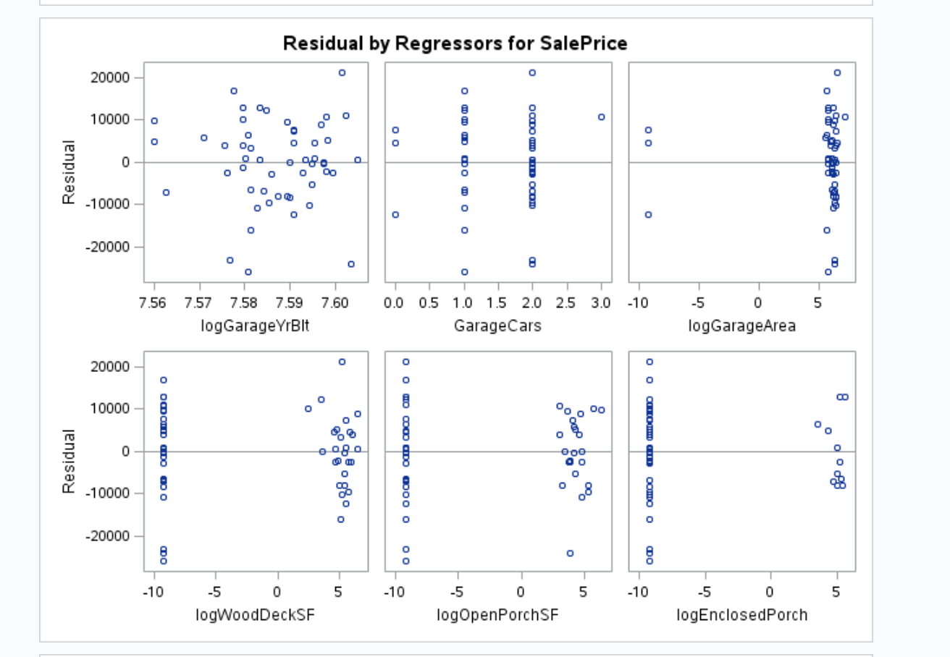

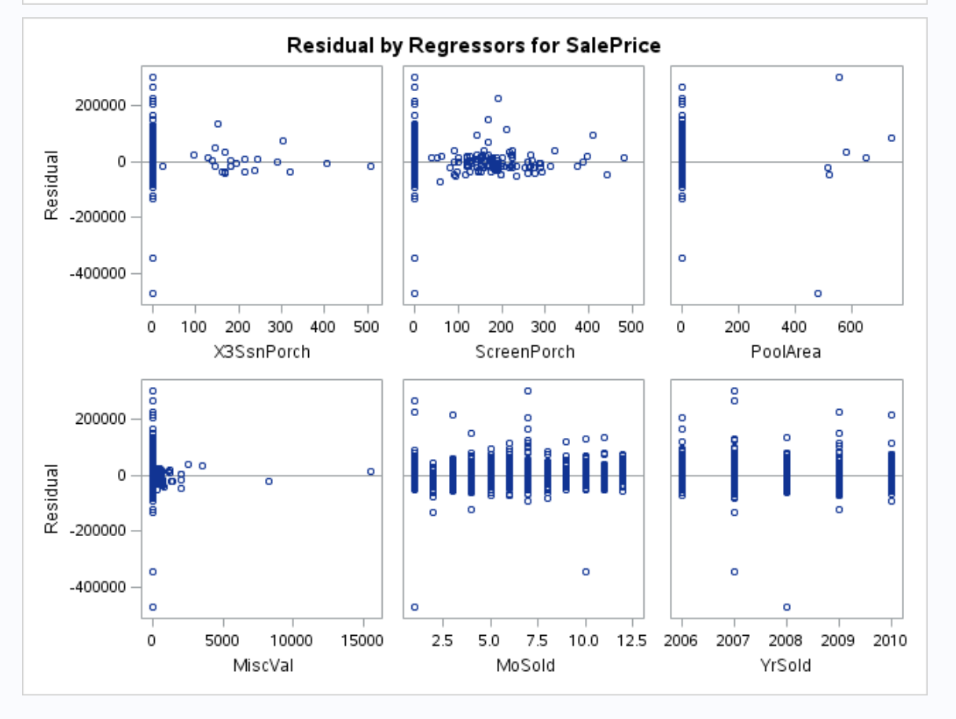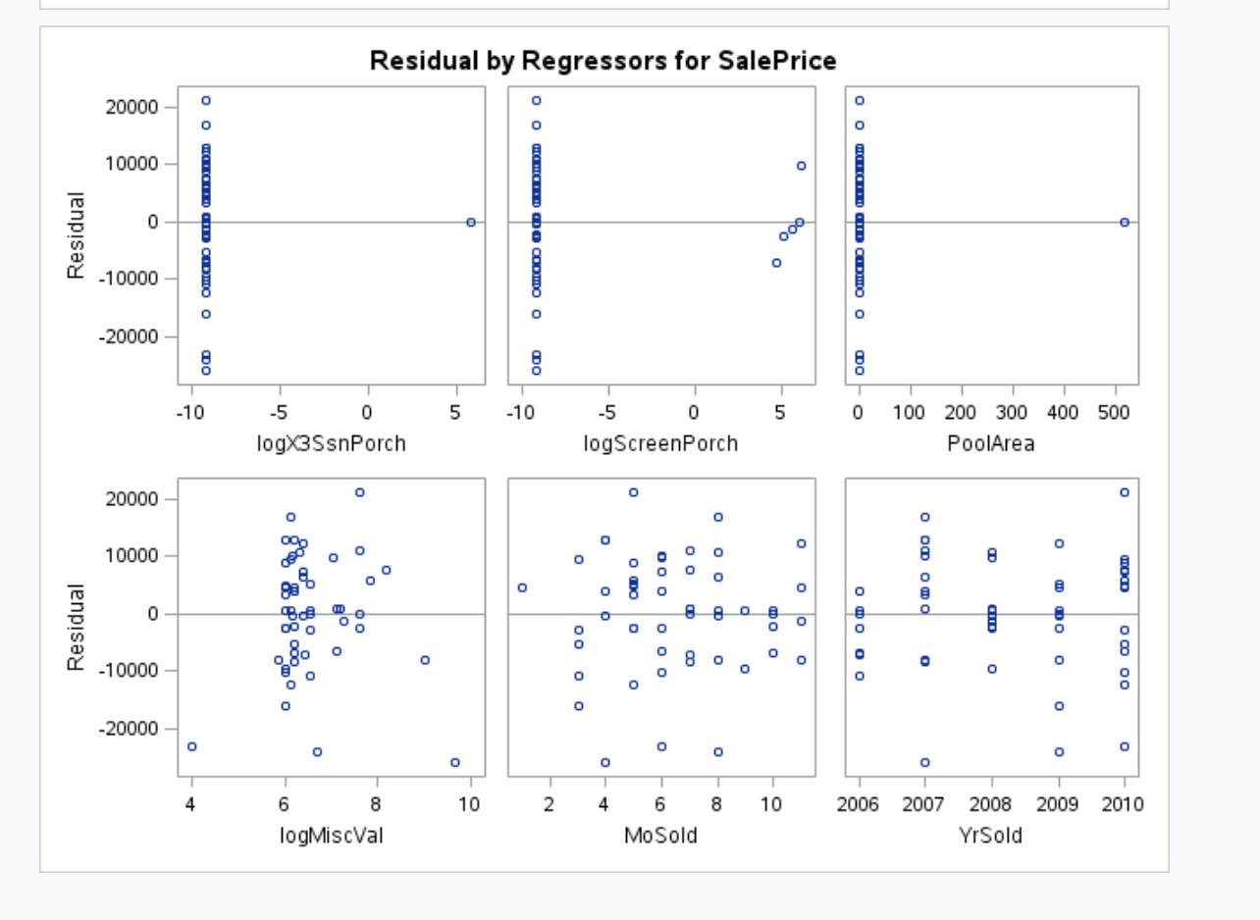

Figure 4 - Residual by Regressor - Before Log on left and After Log on right

# Model Selection (updated)

The goal was to create the most predictive model possible for Sales Price from the most useful variables. The approaches used was FORWARD, LASSO and BACKWARD selection methods. The partition of the training data was at 50%. The best model thus far, using *PROC GLMSELECT,* was LASSO, as shown below.

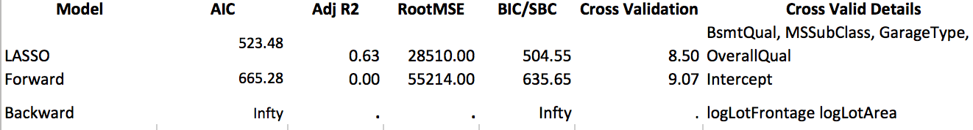

Figure 5 - Model Selection Comparison using partition of Training Data

### From the LASSO model, *PROC GLM* was used to further fit the model. Interactions were tried but the result was not sufficient enough to keep them in the model (Adj R2 .69 vs .7). Interestingly, the interactions in the model degraded the assumptions of Residual Scatter, QQplot and Histogram in the Fit Diagnostics output as to compared to no interactions.

### Below shows the straight LASSO model without interaction. While the QQplot was not ideal, the Residual Scatter does not show any curve and deemed sufficient. The Histogram is within normal ranges and sufficient. It is worth noting that the numerical variables were log transformed but did not make it into the model. Those shown below are categorical variables.

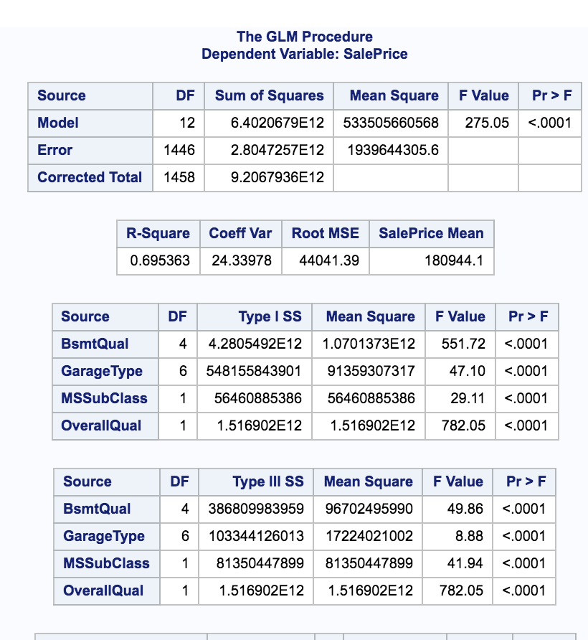

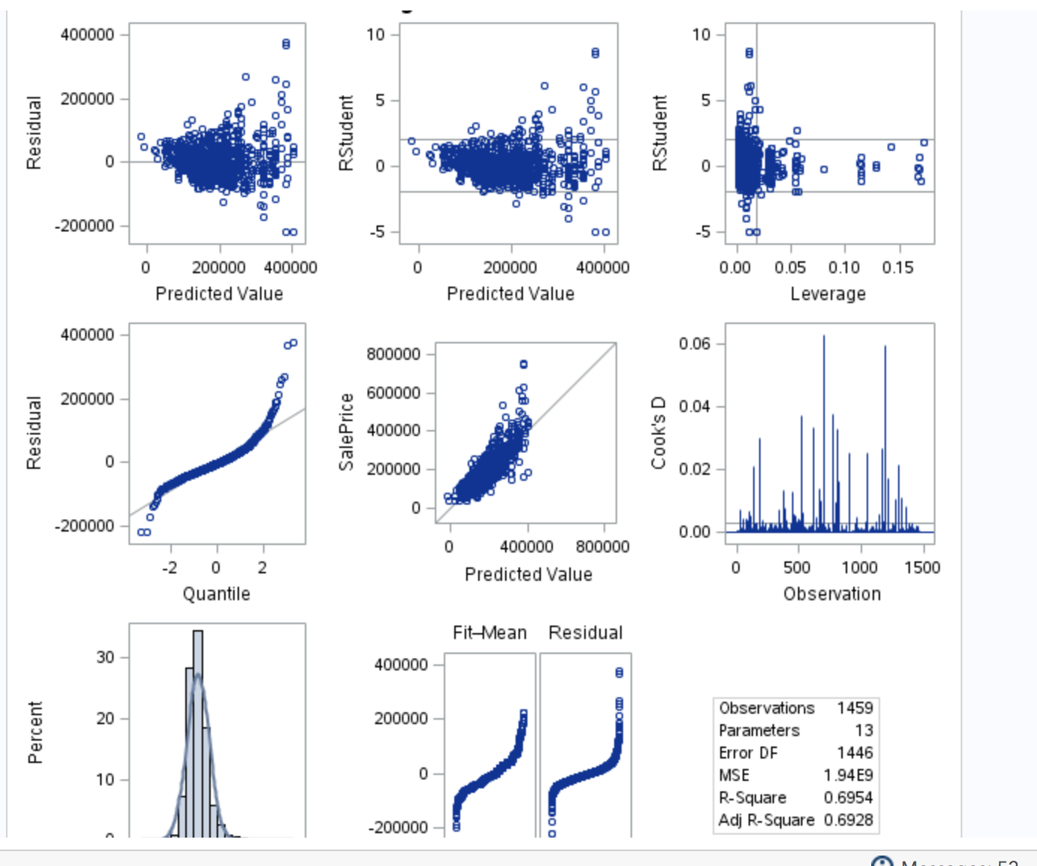

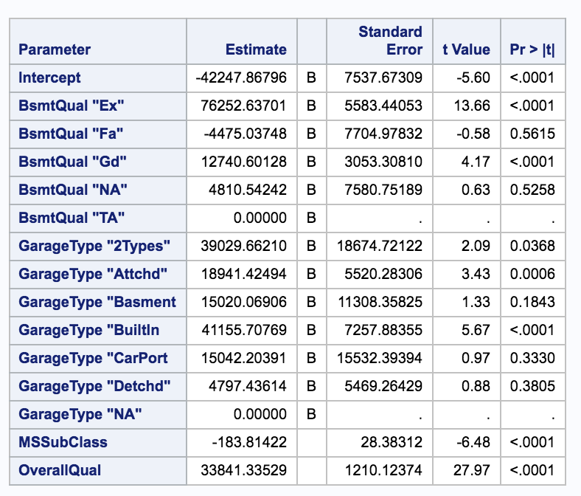

Figure 6 - Linear Regression and Fit Diagnostics for LASSO Model Selection

### Since this is Project 2, no submission to Kaggle was done.

### Project 1 write up has been deleted and moved to Appendix 3.

# Parameter Interpretation (updated)

# 

Figure 7 - Parameter Estimates with Confidence Intervals

SalePrice = Intercept (-42248) + MSSubClass (-184) + OverallQual (33841) + BsmtQualEx (76253) + BsmtQualGd (12741) + GarageType2Type (39030) + GarageTypeAttchd (18941) + GarageTypeBuiltin (41156)

If the Sale Price was $0, the prediction for the cost of the house would be - $42,248.

For every extra $1 in Sale Price, the predicted sales price decreases by $8,951:

Intercept -$42,248

Decrease by $184 for MSSubClass [CI -239, -128]

Increase by $33,841 for OverallQual [CI 31468, 36215]

If the home had the following features, every extra $1 in Sale Price was predicted to be impacted in the following way:

Increase by $76,253 for BsmtQualEx – Basement Quality Excellent [CI 65300, 87205]

Increase by $12,741 for BsmtQualGd – Basement Quality Good [CI 6751, 18730]

Increase by $39,030 for GarageType2Type – assume 2 car garage [CI 2397, 75662]

Increase by $18,941 for GarageTypeAttchd – Attached garage [CI 8112, 29770]

Increase by $41,156 for GarageTypeBuiltin -- Built in garage [CI 26919, 55393]

Since none of the log variables made it to the final model, no back transformation was done.

# Conclusion (updated)

The intercept of the Sale Price at -42248 is an unrealistic starting home price. The potential of features adding and subtracting to the overall Sale Price could be realistic, but still does not seem appropriate or good enough. The coefficient of variation is relatively small at 24.34. The LASSO based model clearly has more linearity than previous attempts.

# Principal Component Analysis

Principal Component Analysis (PCA) was used to select the optimum non-correlated model. Standardization was used in the PCA to select the model “because no one variable was more important; and did not want standard deviation (variance) to determine which variables are placed first.”[2]

Numeric variables submitted into the Principal Component Analysis are as follows:

|  |  |  |  |
| --- | --- | --- | --- |
| MSSubClass | logLotFrontage | logLotArea | OverallQual |
| OverallCond | logYearBuilt | logYearRemodAdd | logMasVnrArea |
| logBsmtFinSF1 | logBsmtFinSF2 | logBsmtUnfSF | logTotalBsmtSF |
| logX1stFlrSF | logX2ndFlrSF | logLowQualFinSF | logGrLivArea |
| logBsmtFullBath | BsmtHalfBath | FullBath | HalfBath |
| BedroomAbvGr | KitchenAbvGr | TotRmsAbvGrd | Fireplaces |
| logGarageYrBlt | GarageCars | logGarageArea | logWoodDeckSF |
| logOpenPorchSF | logEnclosedPorch | logX3SsnPorch | logScreenPorch |
| PoolArea | logMiscVal | MoSold | YrSold |
| SalePrice |  |  |  |

## PCA Selection

The Scree Plot and Variance Explained diagrams indicate about 10 eigenvalues are necessary to explain 80% of the variance.

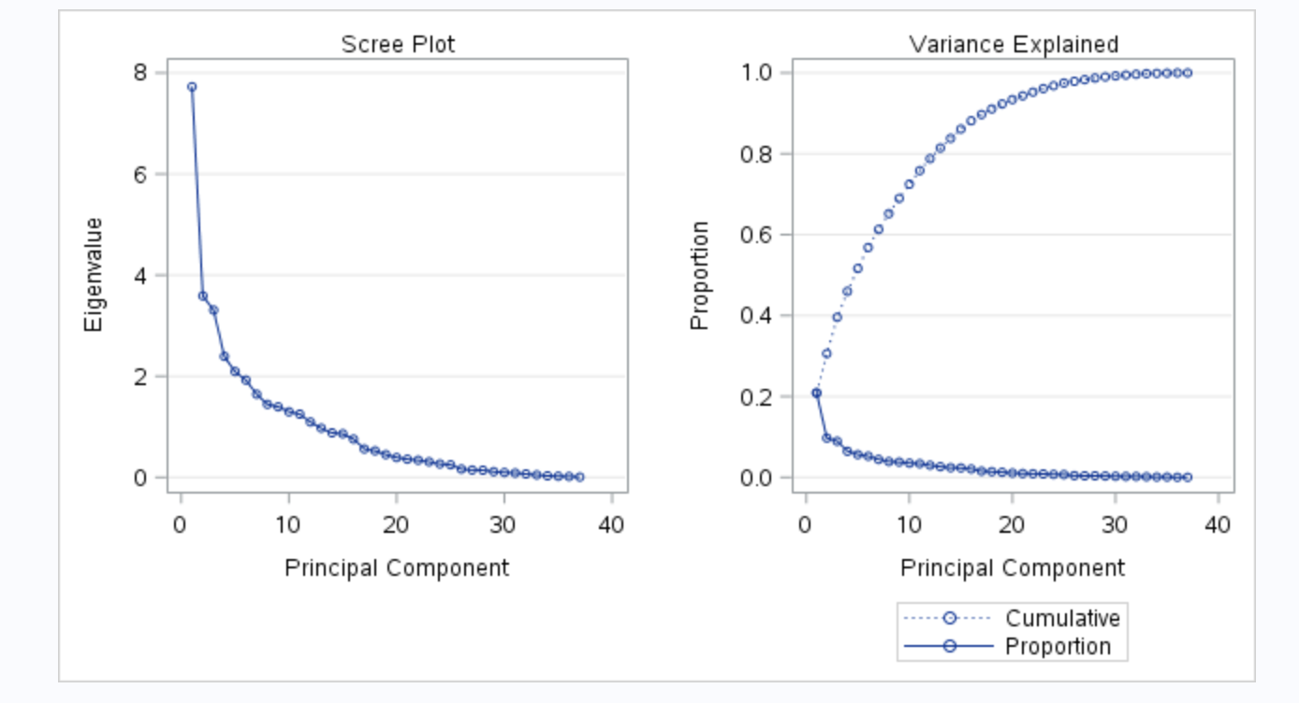

Figure 8 - Scree Plot and Variance Explained Plot for PCA Model Selection

While the Eigenvalues of the Correlation Matrix indicated needing 13 variables to explain 81.43% of the variance. Thus, 13 variables was chosen.

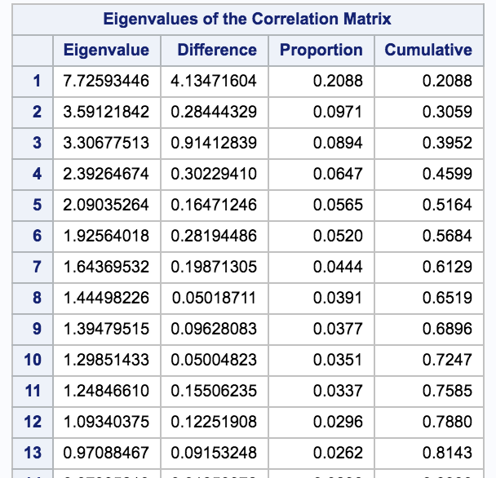

Figure 9 - Eigenvalues for Principal Component Analysis



Figure 10 - Mean for the 13 Eigenvalues

Figure 10 shows that the MSSubClass had a significantly larger mean at 48.55 versus less than 10 for many of the other 13 variables. The meaning of this was to not allow MSSubClass to mask the importance of other variables.

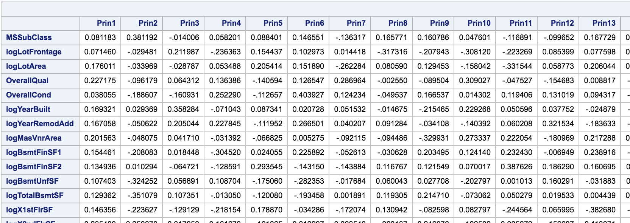

Figure 11 - Eigenvectors for Correlation Matrix

An attempt was made to use ‘%plotit’ macro in SAS to generate a plot of PCA result. While the ODS issues were resolved, the next set of errors were ‘insufficient authorization’ to create a HTML listing. Google searches yielded insufficient documentation on syntax and usage examples that could be digested and used. Consider this attempted but failed. Given the size of the data, even with just 6 factors, an *SGSCATTER* plot exceeded memory and was not useful.

### 11 Factors – Round 1

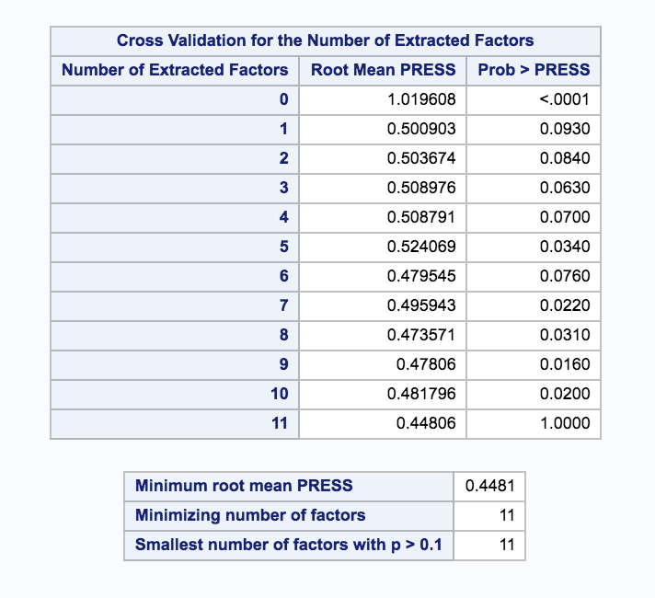

Figure 12 - Proc PLS Summary with 11 Factors – Round 1

The results of partial least squares analysis provided a minimum Predicted Residual Error Sum of Squares (PRESS) statistic of .4481 with 11 extracted factors.

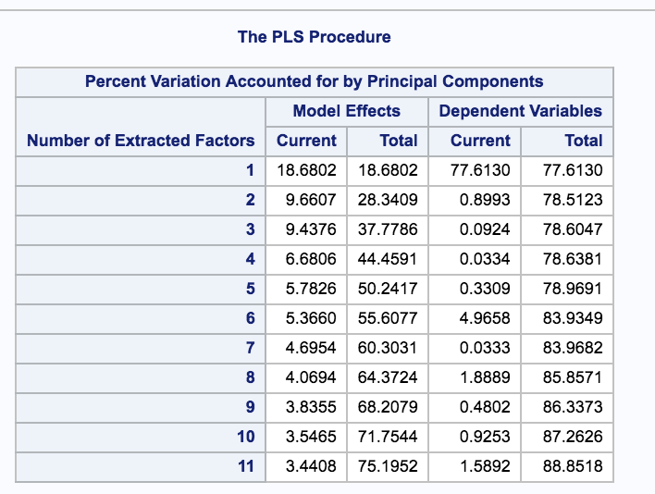

Figure 13 - PLS Explanation of Variance – Round 1 with 11 Factors

Using 11 extracted factors in a Partial Least Squares (PLS) would explain approximately 89% of the variation. The cumulative total of Dependent Variables indicates that 6 Factors would explain approximately 84% of the variance.

### 6 Factors – Round 2

The next attempt was to use 6 extracted factors to balance the number of variables and the amount of variance explained. In this case, six (6) factors explain approximately 84% variance.

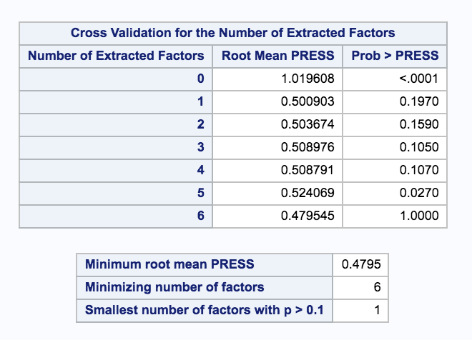

Figure 14 - Proc PLS Summary – Round 2 with 6 Factors

The PRESS changed .03 to approximately .48 (from .448). This is an insignificant increase based on the ability to reduce the number of variables by five (5).

### 1 Factor – Round 3

Interestingly, the PLS showed that using one (1) factor could explain approximately 78% of the variance. The PLS analysis was run to see the result.

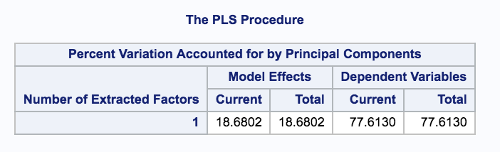

Figure 15 - PLS Explanation of Variance - Round 3 with 1 Factor

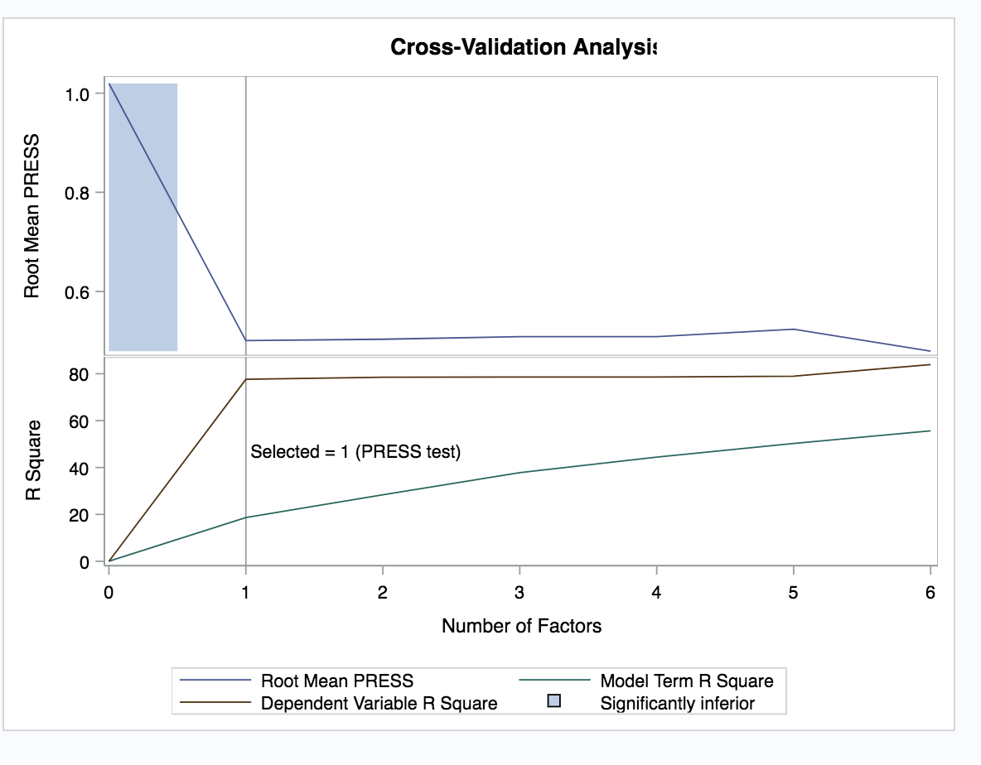

Figure 16 - PLS Cross Validation Graph – Round 3 with 1 Factor

A third round of PLS resulted in an increment of .02 to the PRESS to .50.

Overall from 13 factors to 1, the PRESS only increased .052 [.448 to .50]. Statistically, this could be an acceptable option. From an intuition perspective, it appears more can be learned by including the five (5) missing variables in Round 2 – 6 Factors.

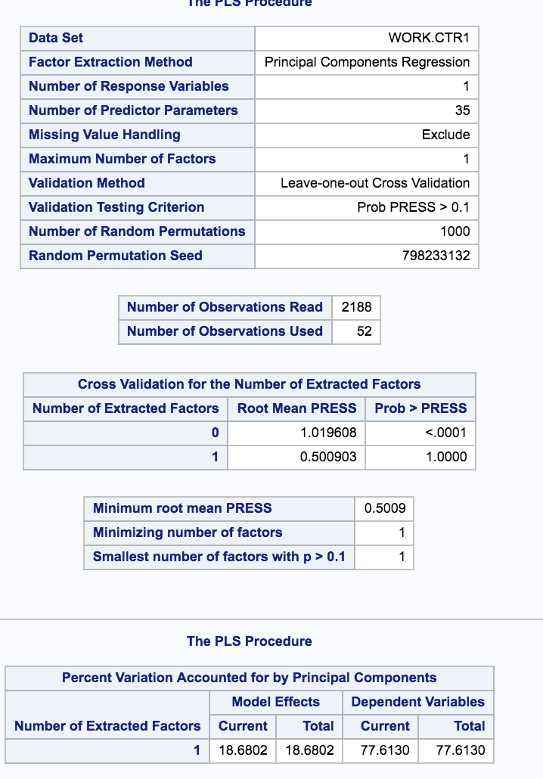

Figure 17 -PLS Explanation of Variance – Round 3 with 1 Factor

## Analysis Based on PCA Selected Model

Model selection based on the six variables chosen through the PCA were MSSubClass, logLotFrontage, logLotArea, OverallQual, OverallCond, and logYearBuilt.

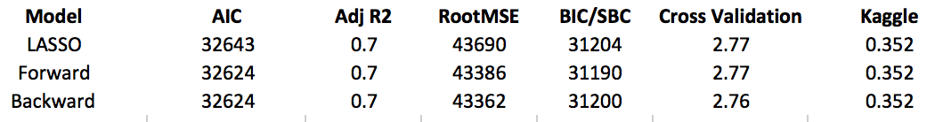

Figure 18 - PCA Model Analysis Results

Each of the three model selection approaches yielded very similar results. Backward yielded the best results with Cross Validation being the real tie breaker of .001 difference.

Interestingly, the redo of the original analysis (Project 1), the Backward Model did not even register any numeric results. And now it was the best model approach by a slim margin.

## PCA Backward Model Parameter Interpretation

SalePrice = Intercept (ln -6637093) + MSSubClass (53) + logLotFrontage (ln6644) + logLotArea (ln40632) + OverallQual (37447) + OverallCond (3241) + logYearBuilt (ln813363).

Rewritten in exponential form:

SalePrice = Intercept (-7) + MSSubClass (53) + LotFrontage (4) + LotArea (4.6) + OverallQual (37447) + OverallCond (3241) + YearBuilt (6).

If the Sale Price was $0, the prediction for the cost of the house would be $ -7.

For every extra $1 in Sale Price, the predicted sales price increases by $40,749:

Intercept -$7

Increase by $53 for MSSubClass [CI -9.7, 115.7]

Increase by $4 for LotFrontage [CI -3.5, 4.2]

Increase by $4.6 for LotArea [CI 4.5, 4.6]

Increase by $37447 for OverallQual [CI 3584, 39511]

Increase by $3241 for OverallCond [CI 1044, 5438]

Increase by $6 for YearBuilt [CI 5.8, 6.0]

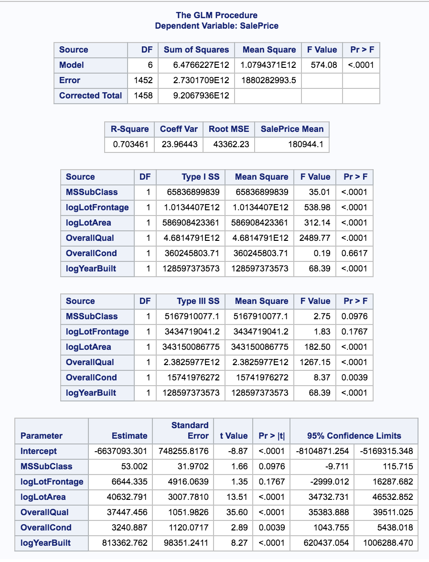

Figure 19 - PCA Model Backward Selection Linear Regression

## PCA Model Conclusion

Principal Component Analysis was a much better way to reduce the number of variables, especially when dealing with large number of variables. The variables selected and the model interpretation also make logical sense in the real world. Having a home price at -$7 in Ames IA would not be unfathomable. The impact of all the variables chosen on the price makes sense. The Adj R2 of .7 also strengthens the model’s usability.

# Linear Discriminant Analysis

Fishers. Compare 2 groups.

# Conclusion

The software engineering discipline taught that the human brain can grasp 7 – plus or minus 2 things at once.[3] Working with 80 variables was beyond comprehension and added unnecessary complexity. Techniques like PCA and LDA are ways to allow computers to manage the complexity and get the model down to a size the human brain can conceptualize. Statistical evaluation metrics like PRESS, AIC, SBC/BIC, Adjusted R2 allow the Data Scientist to determine if model contained any value.

# Addressing Comments

Complimentary comments are being skipped. Thank you for the kind words.

Comment: *I think it will look better without the dot in front of each section title*.

Response: There is no ‘dot’ in front of MSWord Heading1 on my Mac version. Likely this is a compatibility issue. A PDF will be used to eliminate this problem.

Comment: *Scatter plots, histograms, correlation matrix are expected for EDA.*

Response: The Exploratory section has been reassessed and rewritten.

Comment: *I suppose you meant external cross validation is performed but I didn’t see the data partitioning step in your code. This needs a little clarification.*

*I checked your code and see your CV methods in code which is used to build the model using the whole train.csv. But I view it as an internal CV. Our project description says “internal CV Press required” and “We will say that an external cross validation is mandatory to compare the adjusted R2 and AIC of competing models based on the validation dataset.”*

Response: My understanding was using all of the data as “train” to train the model, then use same data in test to do the testing and submit to Kaggle. This was lack of understanding on my part. This was redone for the new model approach in Project 2.

Comment: *The intercept means, when all predictors are 0, the sale price is -$44063.*

Response: See the new Parameter Interpretation section.

Comment: *“*Coefficient of Variation of 110.0 seems high as a unit-less number. *“*

*Don’t really understand this.*

Response: The statement was referring to the interpretation of 110.0. If the Coefficient of Variation represented the variation on housing price, say $110.00 in relation to a home that sells for hundreds of thousands of dollars, it is small. The result of the new LASSO model changes the coefficient to 24.34.

Comment: If the Sales Price increases by $1, the Model predicts Basement Full Bath (BsmtFullBath) will decrease Sales Price by approximately $43,554

*When you interpret the coefficient in regression model, focus on how one unit increase of the predictor will impact the response. Don’t start with the change of response.*

Response: See new Parameter Interpretation section.

Comment: *“The model exhibits enough of a Normal distribution with adequate scatter…”*

*Again, the variance is clearly not constant*

Response: Chose to rework the EDA and the approach. See the Exploratory Data Analysis section.

Comment: *Are there two captions given to the same table? There is already one title above this table.*

Response: Proof reading error. Fixed.

Comment: *Where is equilibrium? Not sure at this point, but recognize that the data mining effort was clearly not worth the effort.*

Response: Chose to rework the EDA and the approach.

Comments: Data Mine Model comments.

Response: This approach was eliminated in Project 2 so the comments are understood, but not addressed.

# Appendix 1 – Code Project 2

## EDA – update – Project 1 Redo

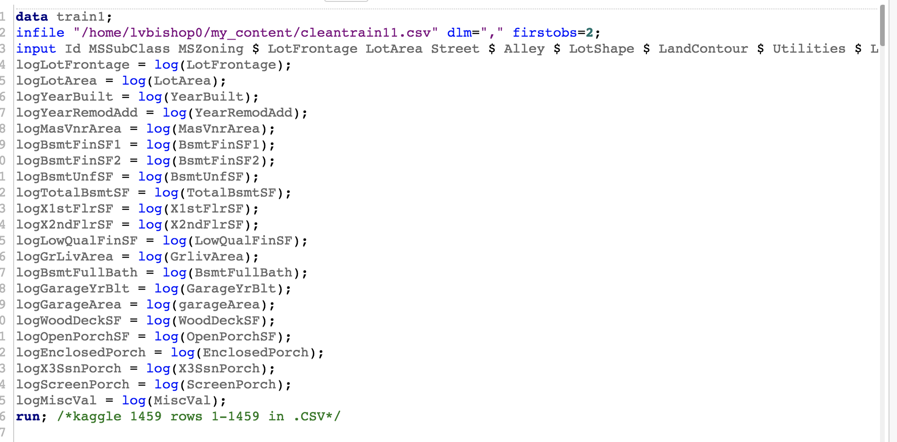

## 

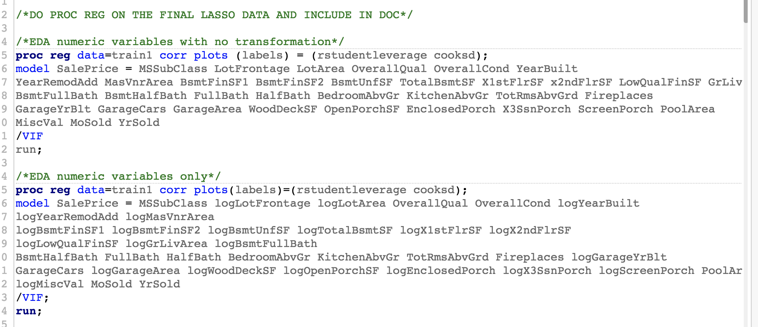

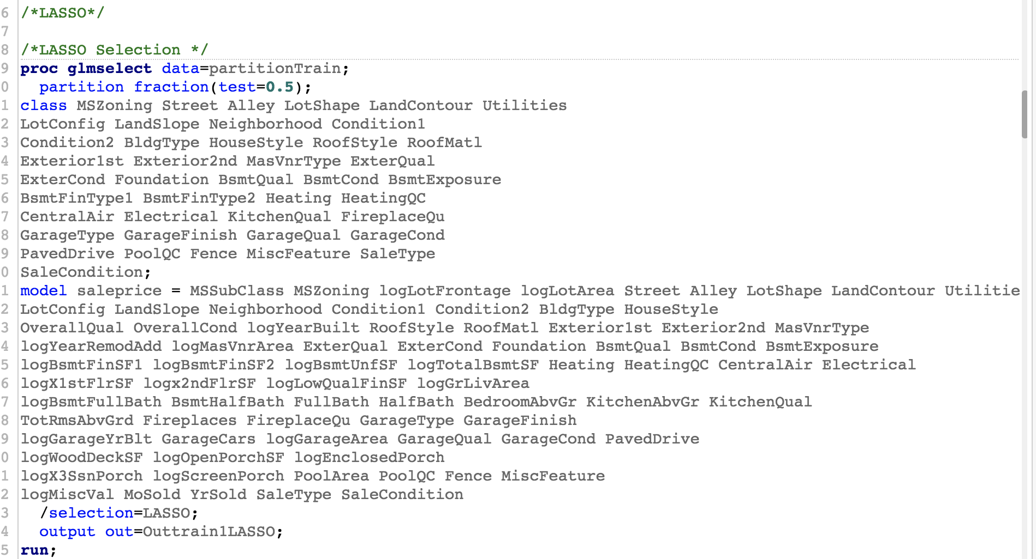

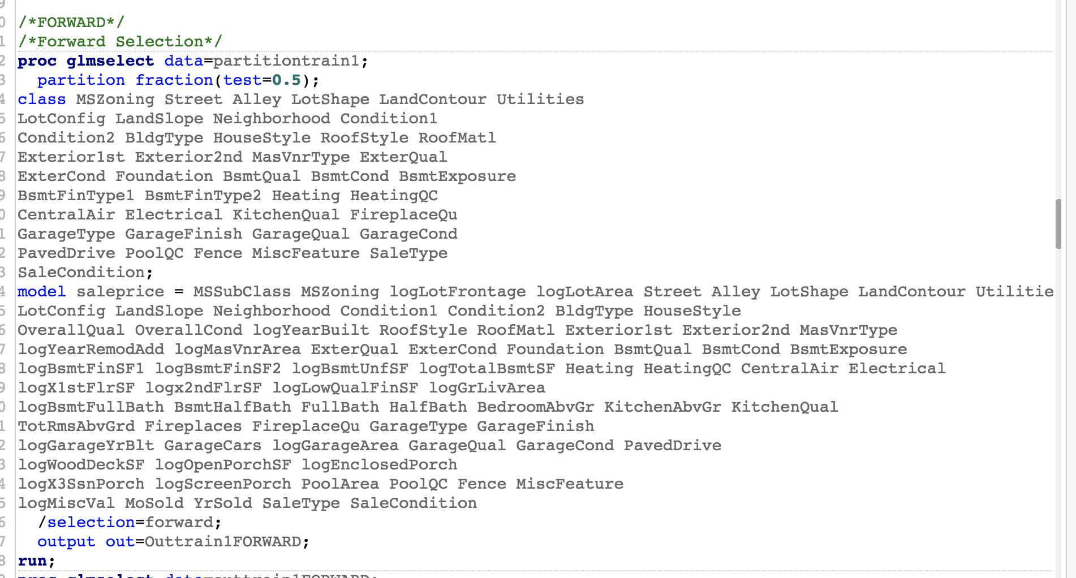

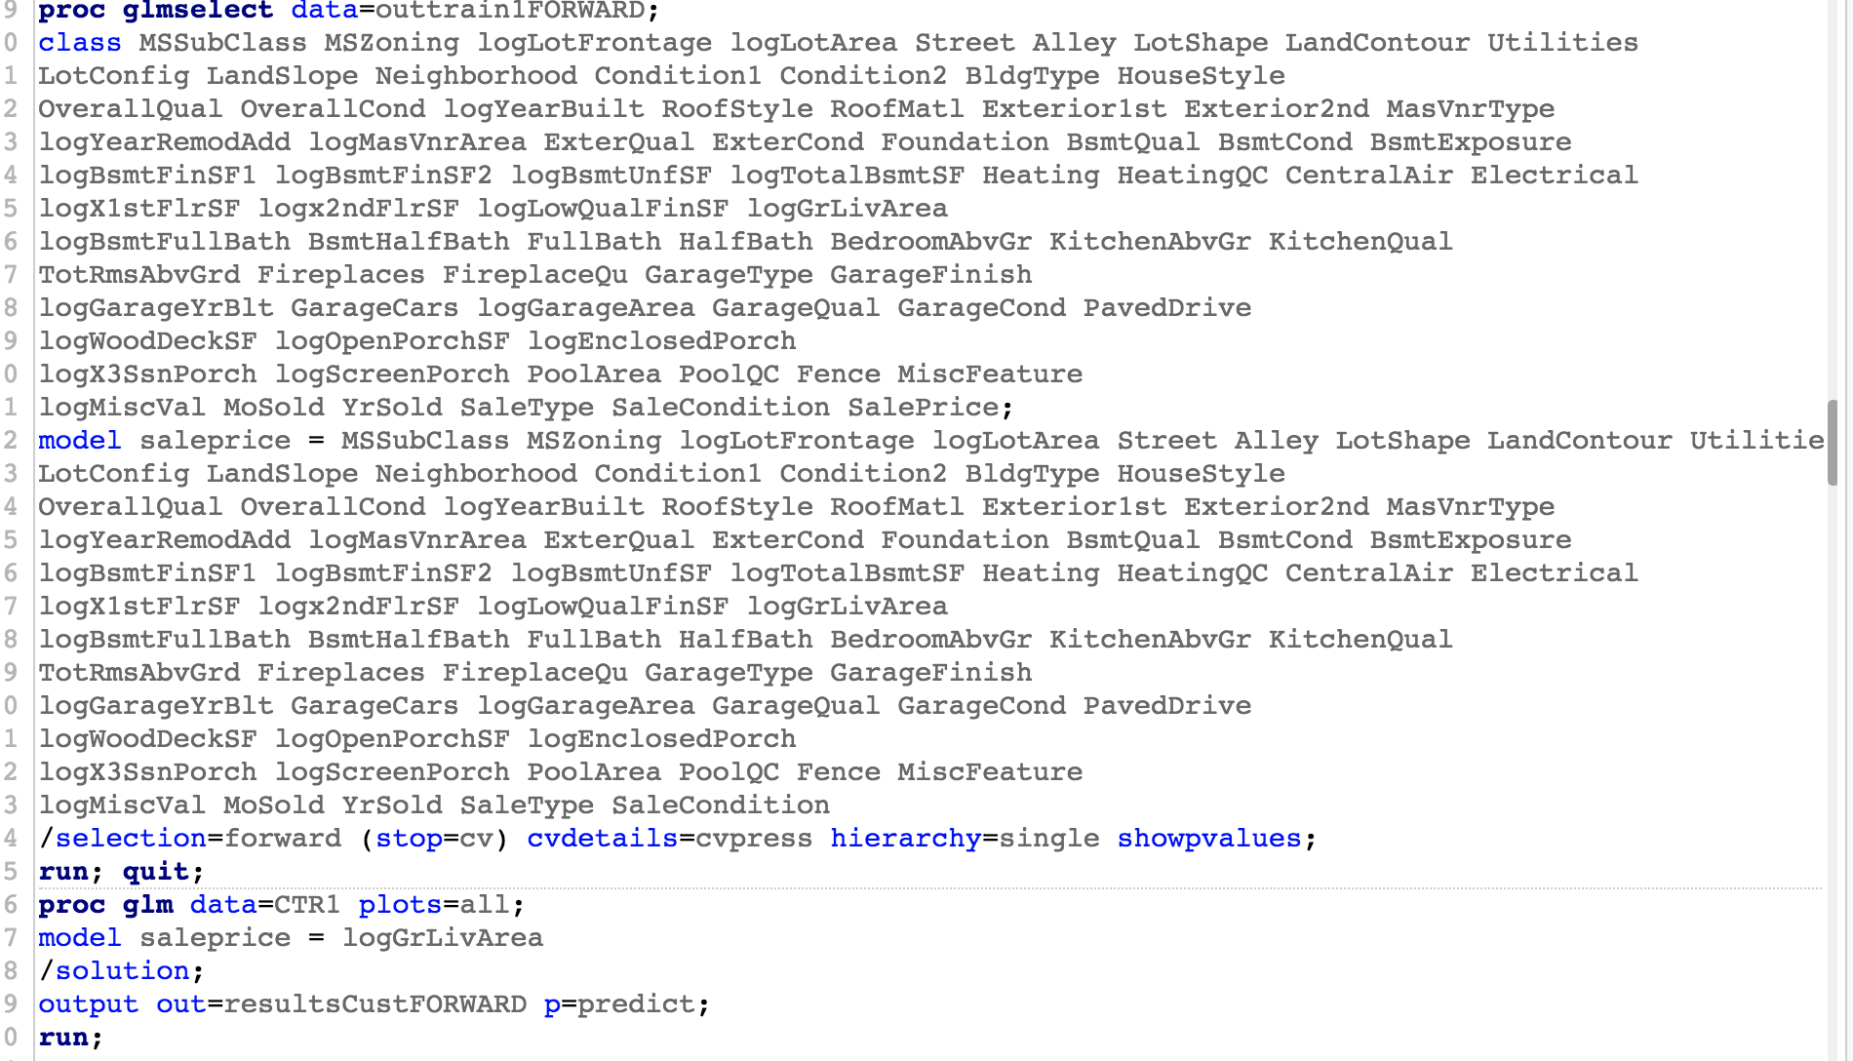

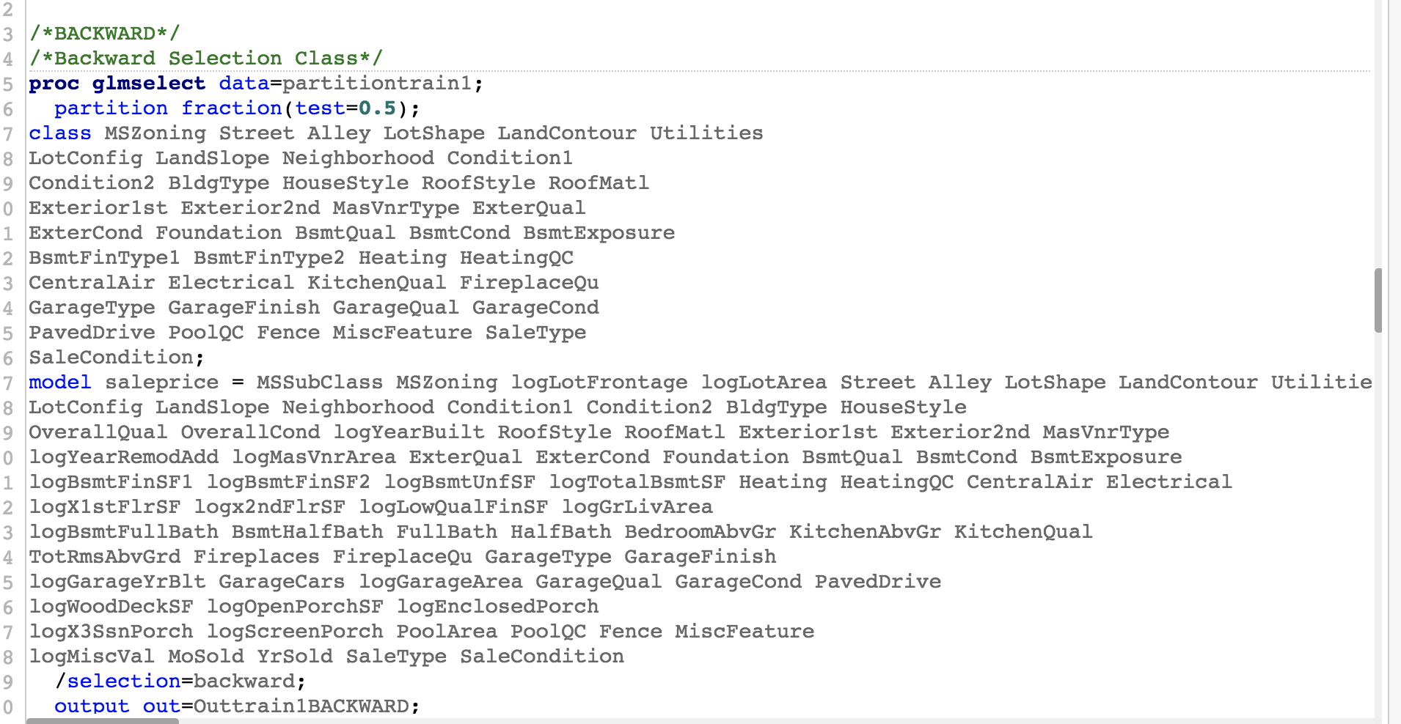

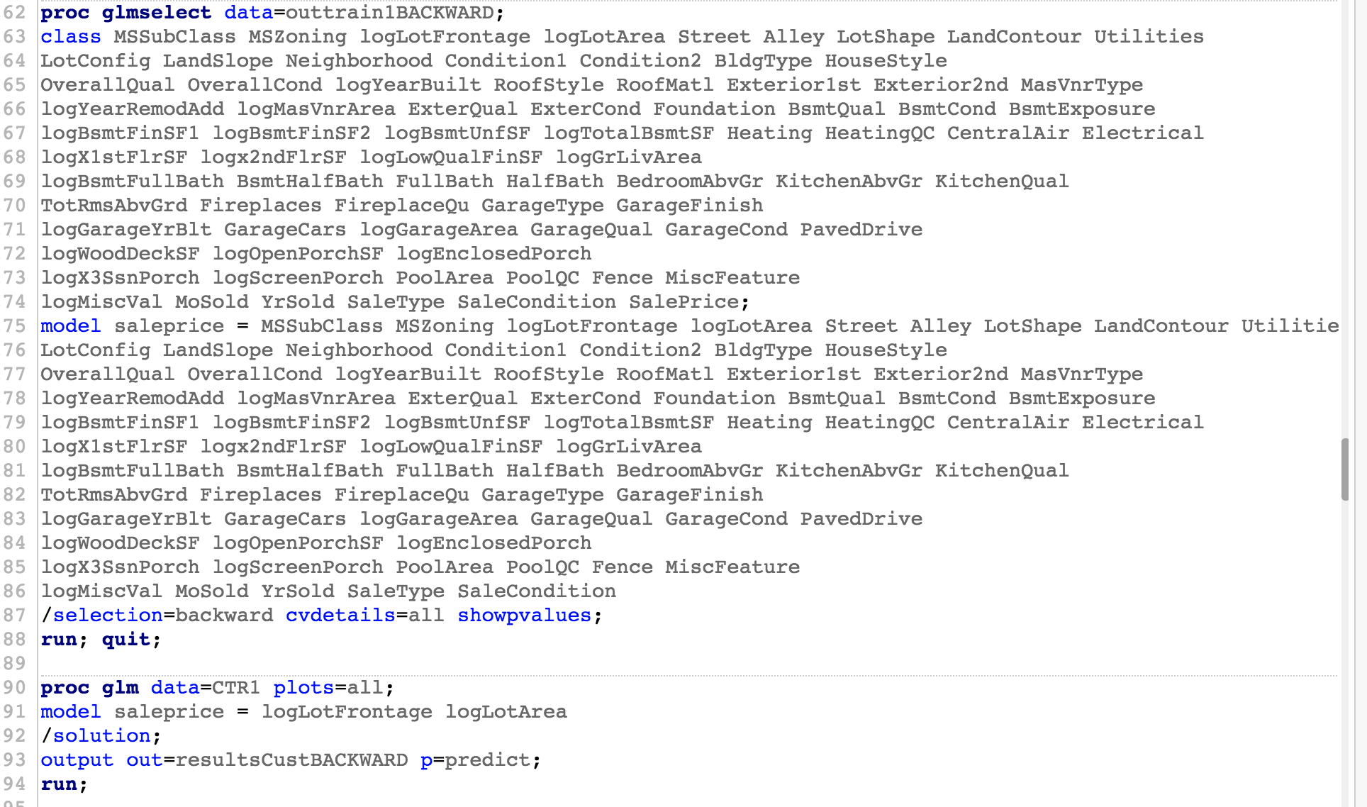

## Principal Component Analysis Code

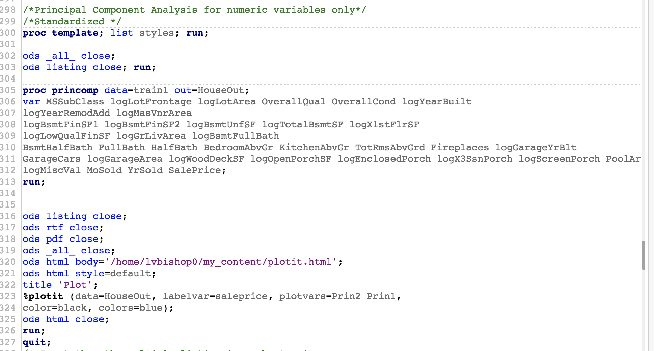

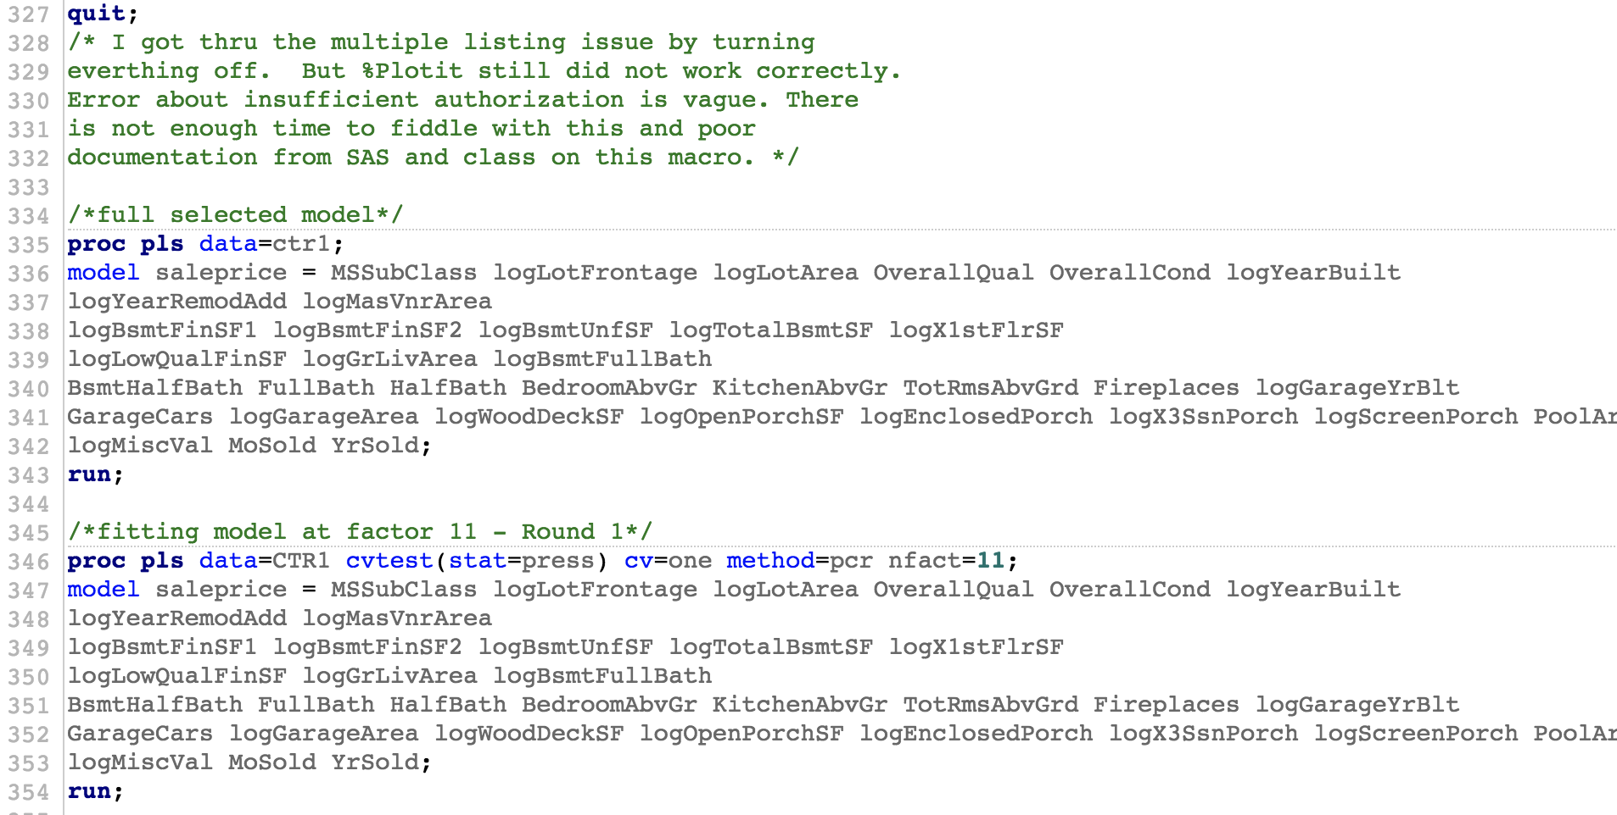

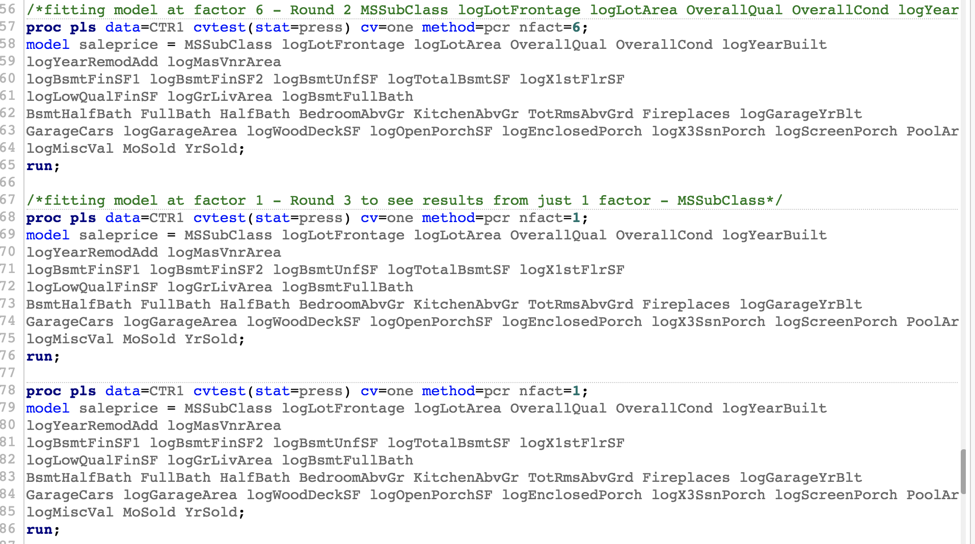

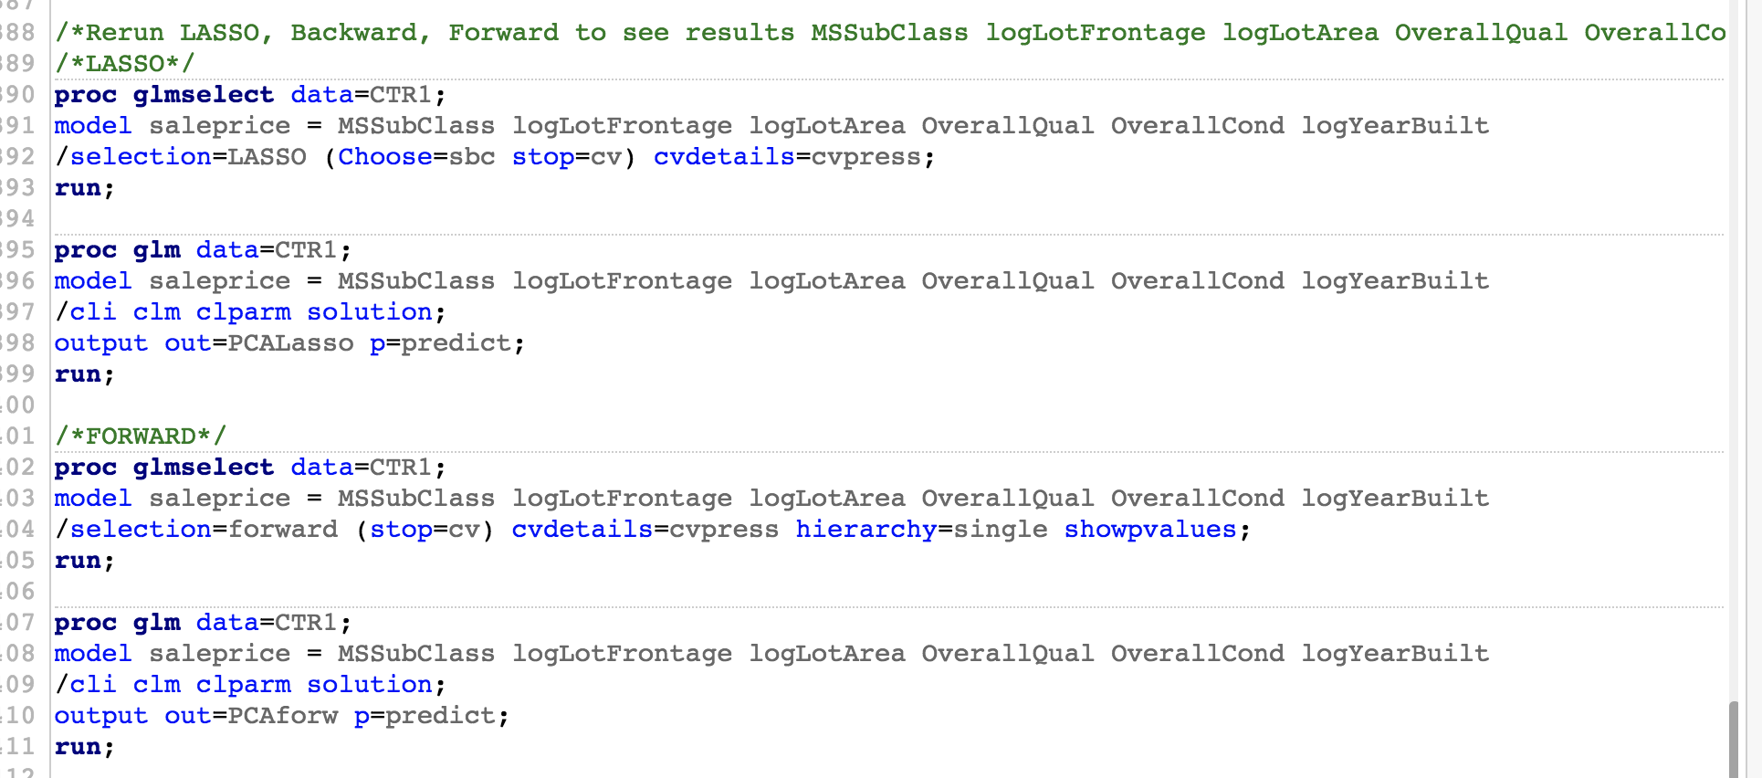

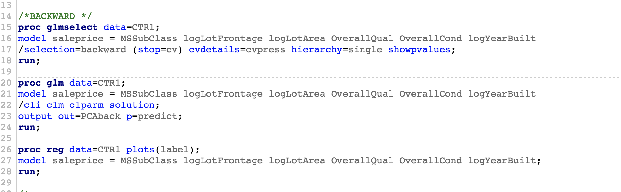

### PCA Kaggle Submission Code

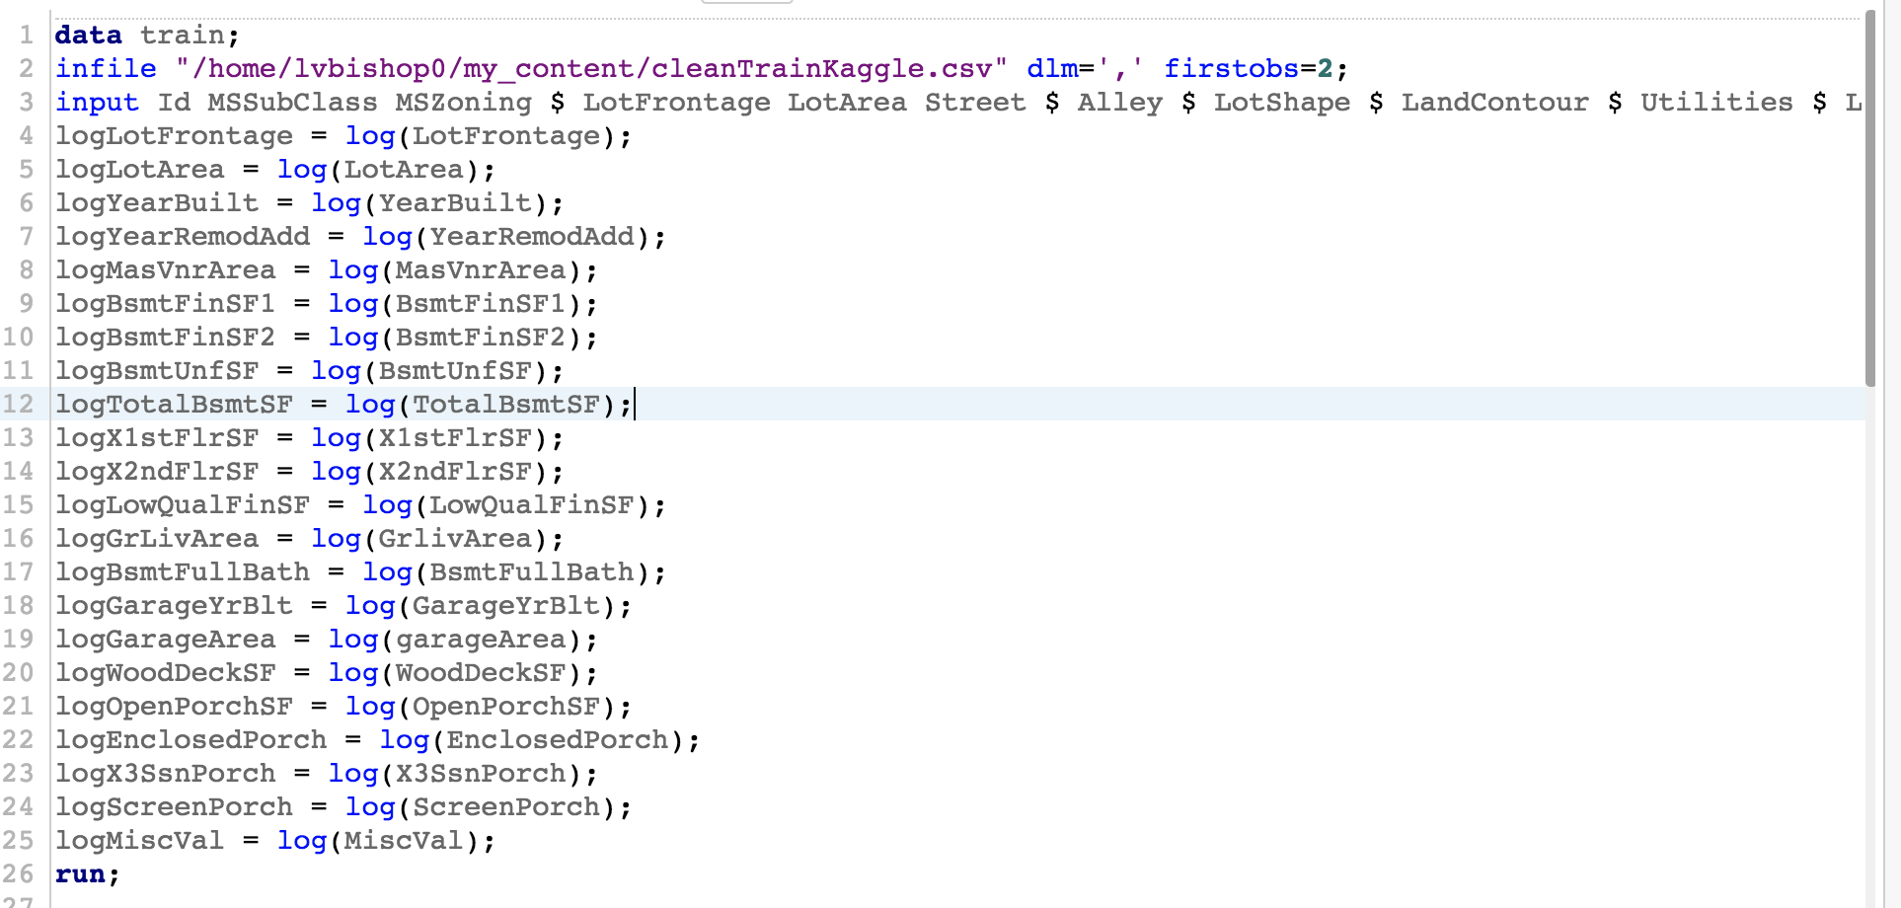

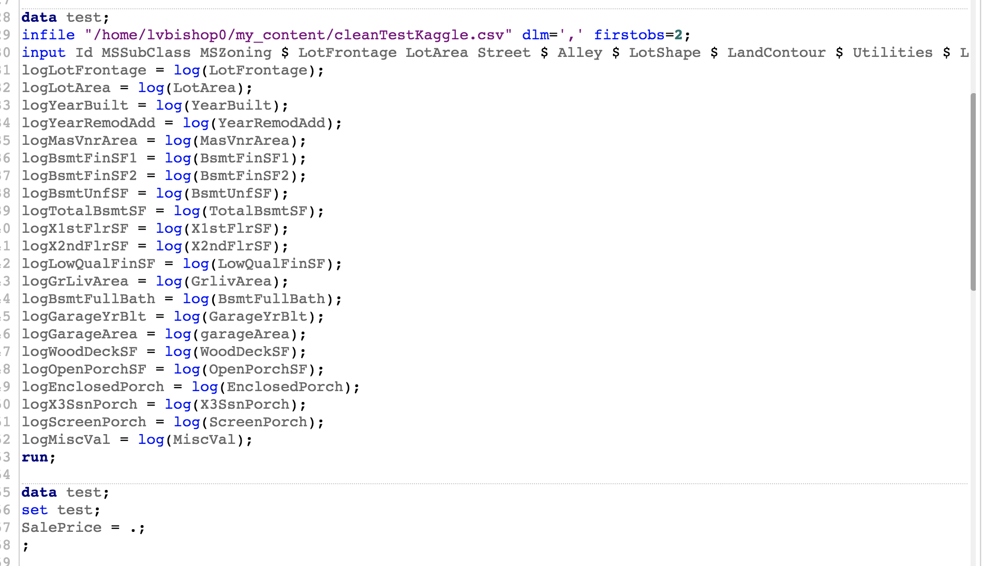

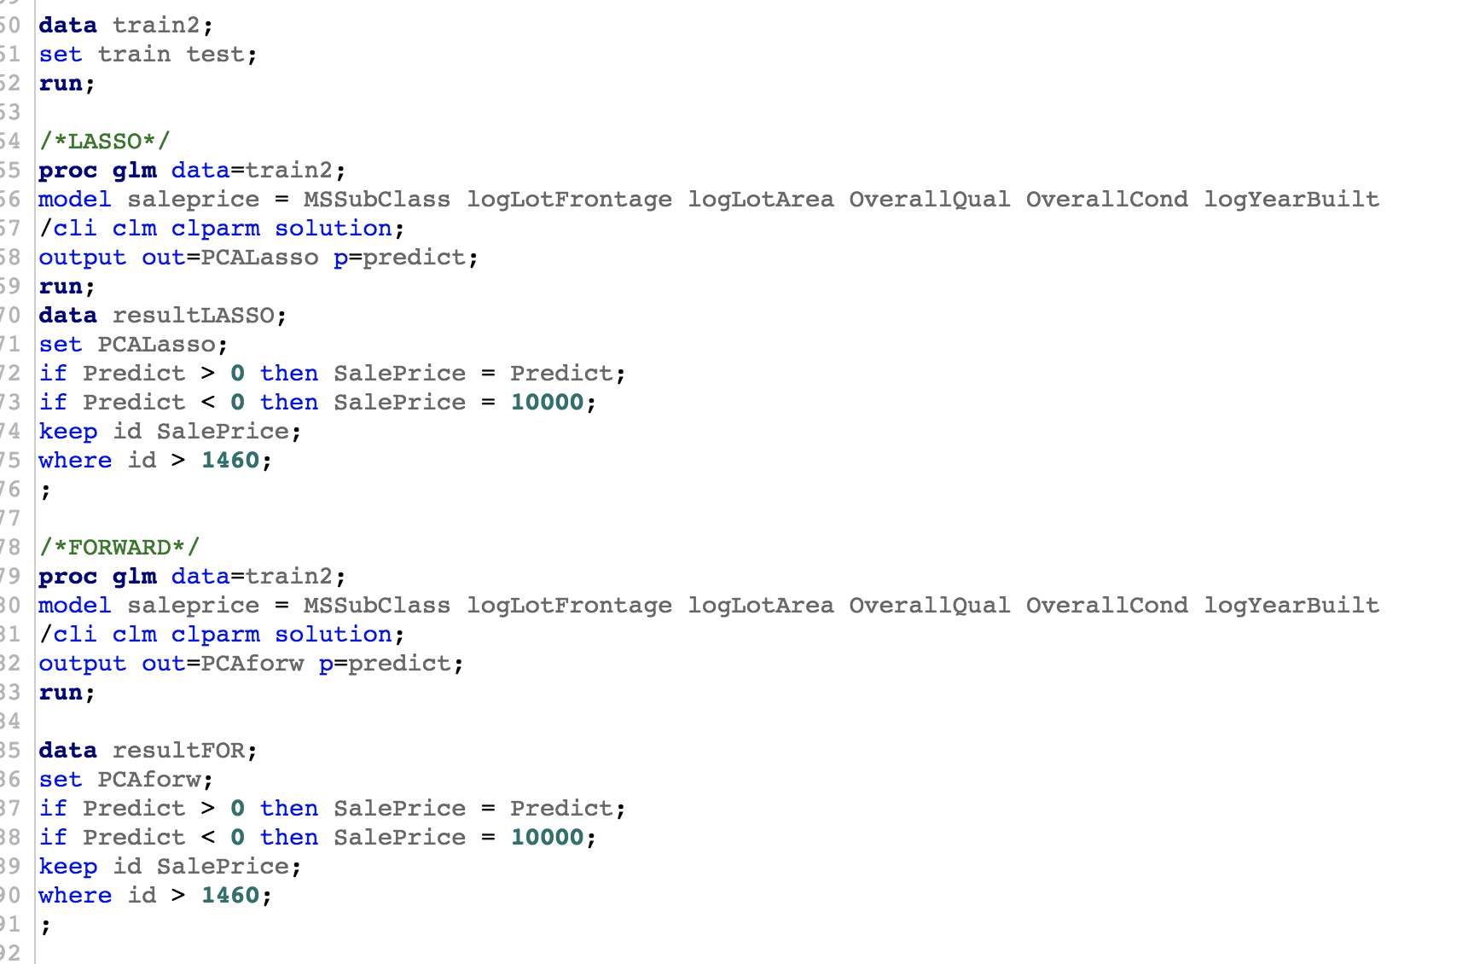

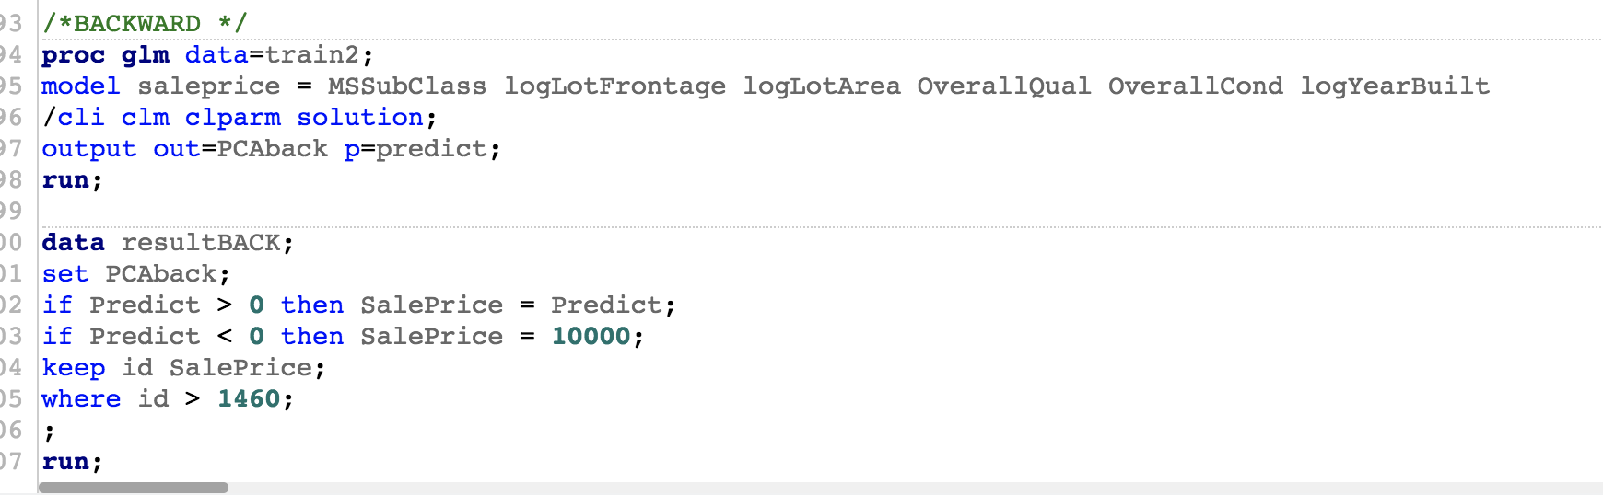

## Linear Discrimination Code

# Appendix 2 – Project 1 CODE

## Code

### Model 1 - Forward

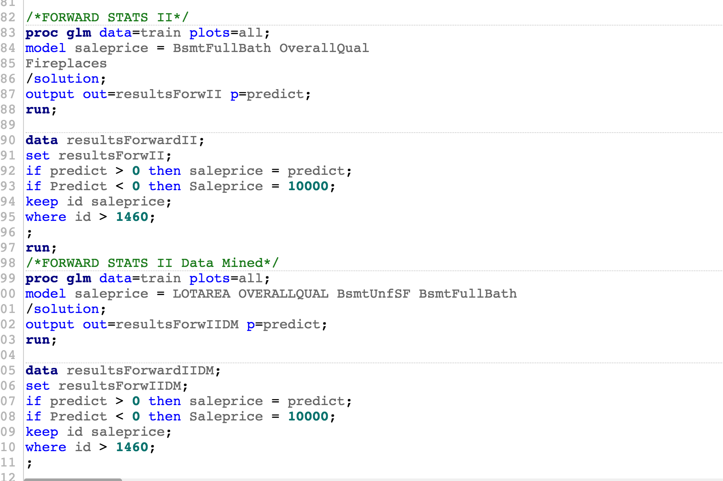

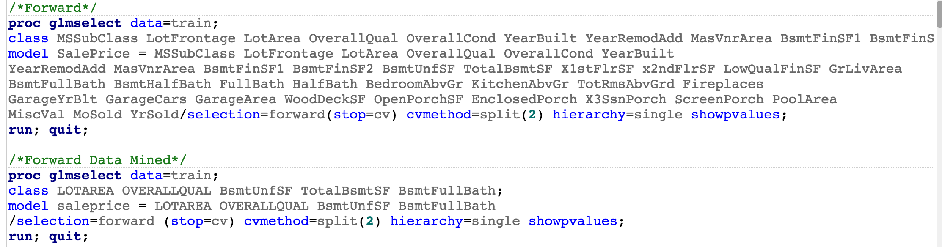

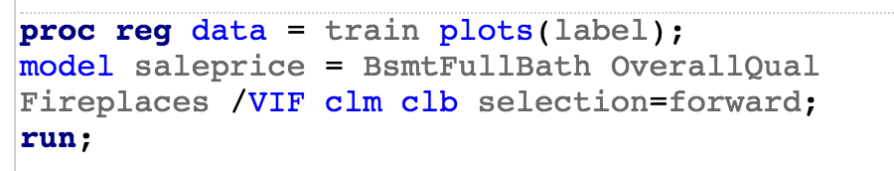



### Model 2 - LASSO

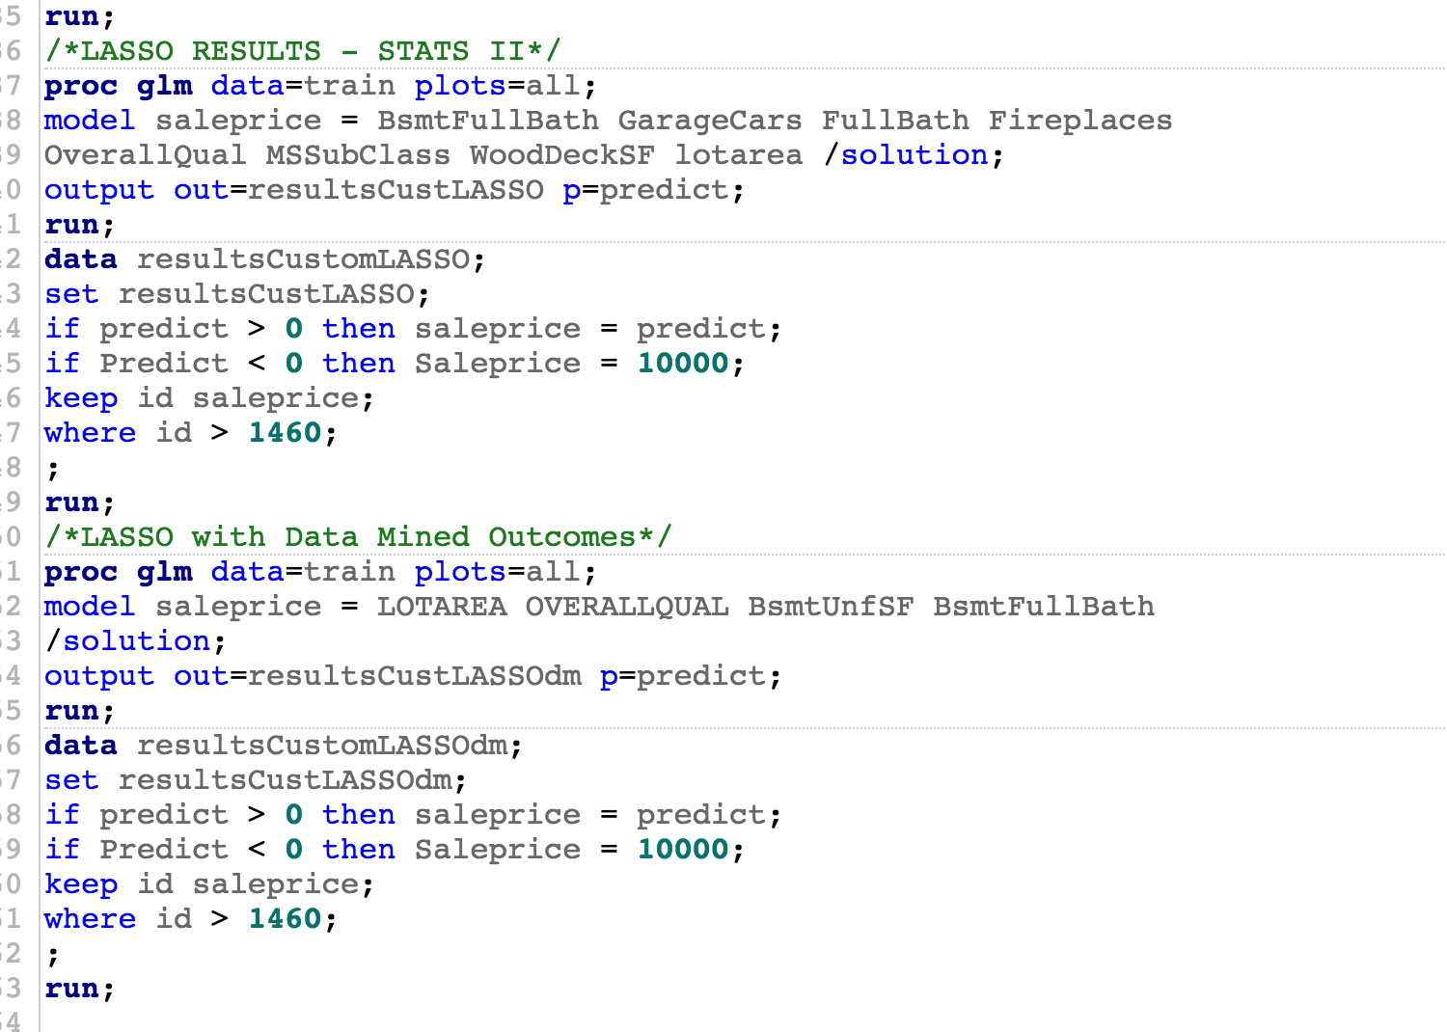

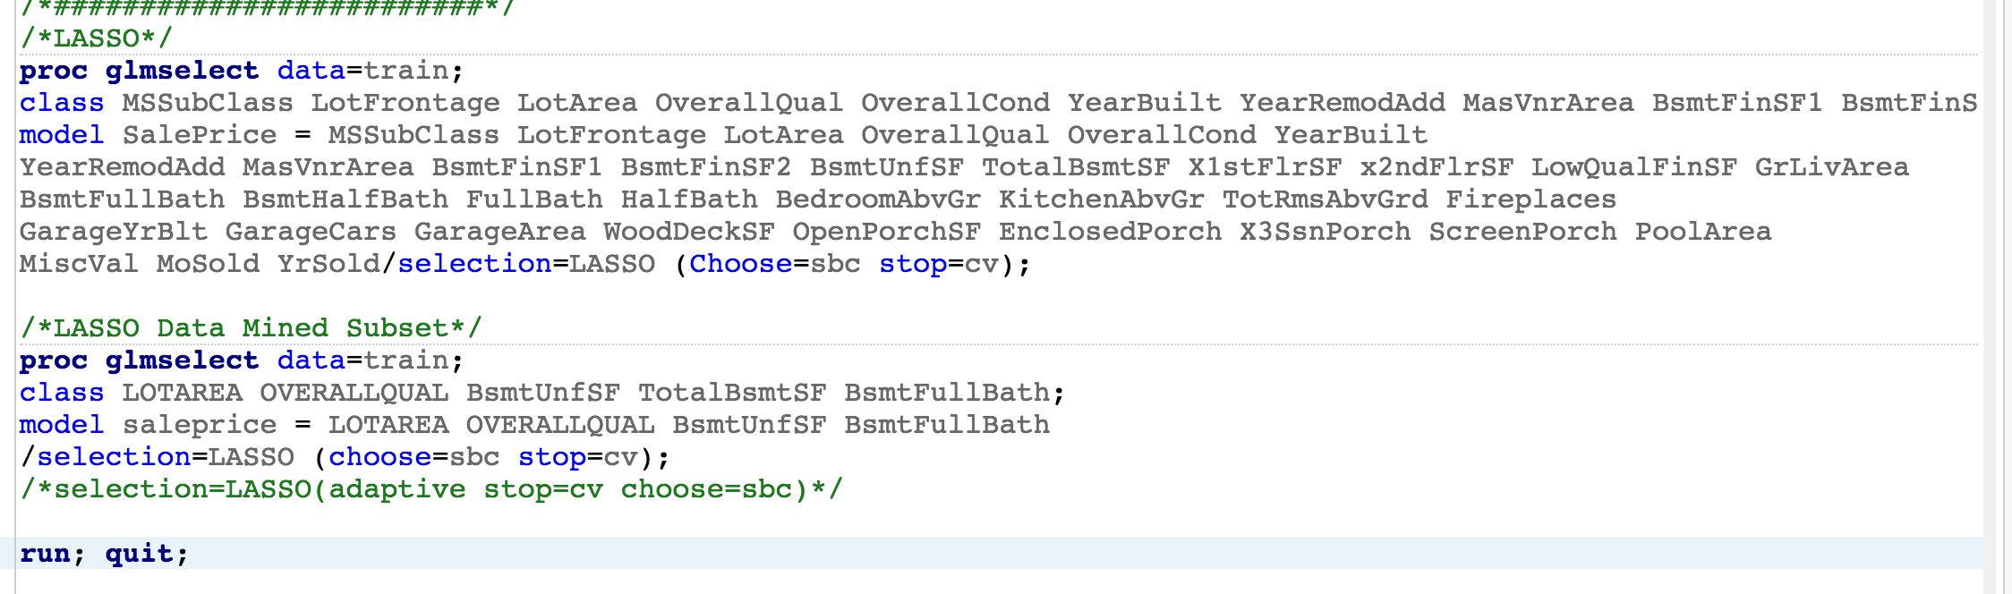

### Model 3 - Stepwise

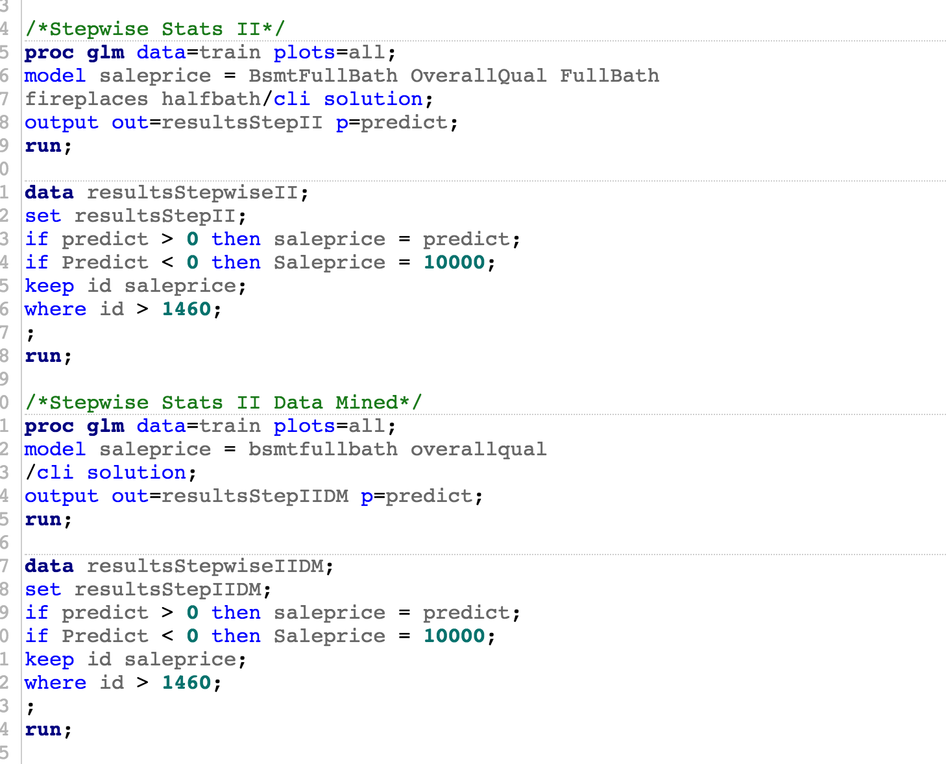

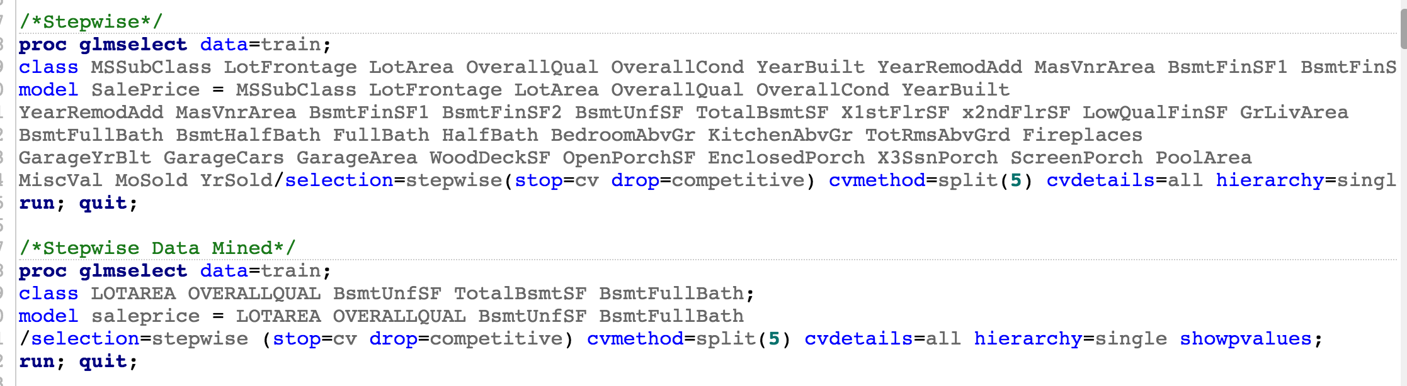

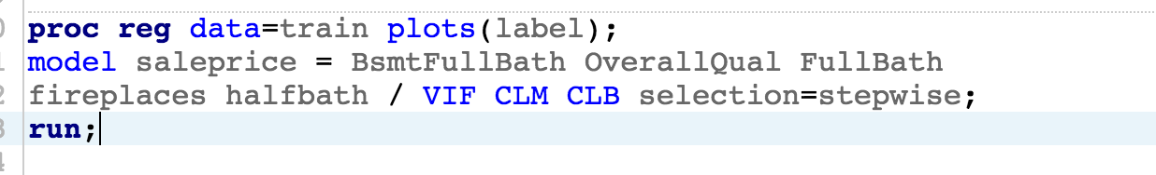



### Model 4 - Human

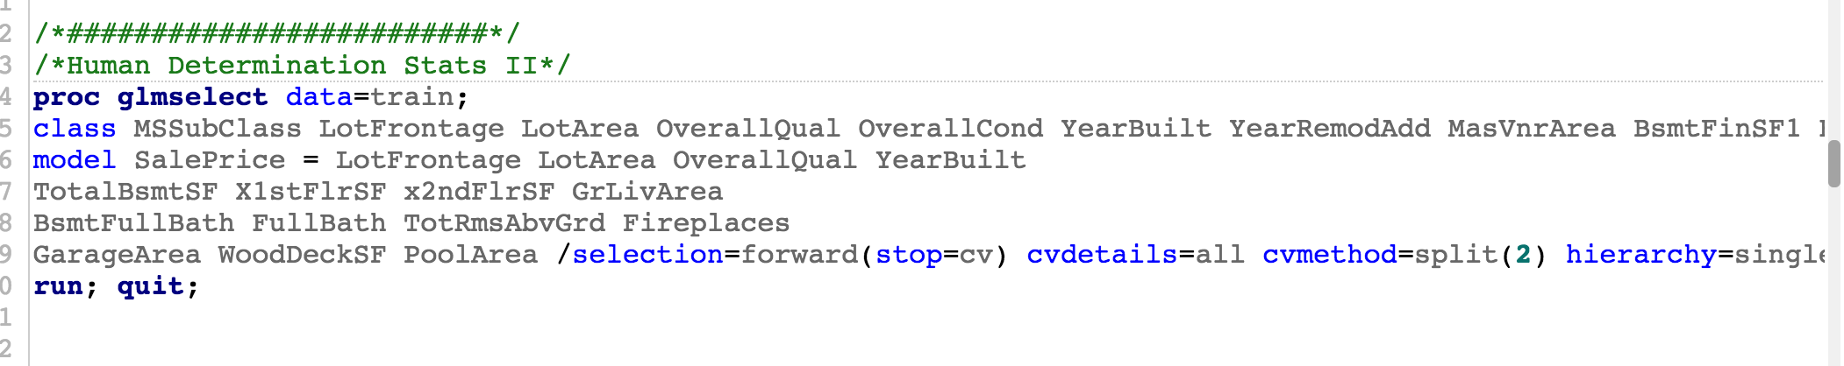

1. Estimation Methods for Replacing Missing Values, <https://www.ibm.com/support/knowledgecenter/en/SSLVMB_20.0.0/com.ibm.spss.statistics.help/replace_missing_values_estimation_methods.htm>
2. Xing, Dr. Penelope, Unit8Slides_2_2_2_2, Slide 4.
3. Grady Booch, Object-Oriented Design talk Rational Software, 1994.